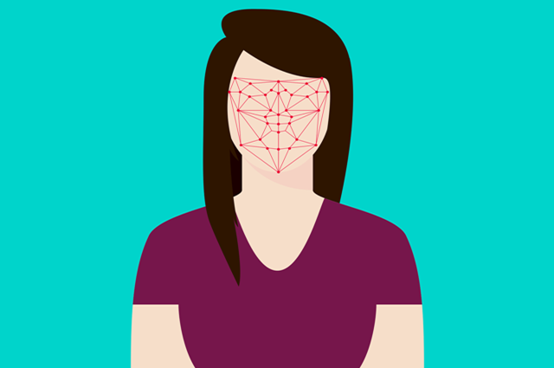
Worksheet 1

Scenario 1 Face recognition
- Choose one of these options to investigate the benefits, risks and possible impacts of facial recognition applications.
- Use the Analysis worksheet: ethical considerations to record your ideas.

Option A
Face recognition is increasingly being used by the Australian Border Force to determine if a person should be allowed to enter the country.
You may have seen this at international airports, where people can have their passport scanned and photos of their faces taken.
The computer then checks a database, which determines if the passport holder and the person in front of the camera are the same, and if that person is a citizen of Australia or a valid visa holder.
If the answers are all ‘yes’, then a gate opens to let the person walk through.

Option B
Airlines use AI to improve the efficiency of boarding a plane at the airport by automating the process of baggage drop-off, getting a boarding pass and matching you with your passport using facial recognition software.
View the video Don’t smile for surveillance: Why airport face scans are a privacy trap. Although this video features US airports and related US-based protocols, it provides some of the fundamentals about the technology – and some of its pitfalls.

Scenario 2: AI powered skin cancer app
- Use the suggested links to learn more about AI technology used to diagnose skin cancers.
- Use the Analysis worksheet: ethical considerations to record your ideas.

Skin cancer statistics
Did you know that in 2018 Australia as it had the highest rate of melanoma skin cancer in the world?
For statistics related to skin cancer refer to: Skin cancer statistics

Smartphone apps with AI technology
Smartphone apps with AI technology are assisting people to diagnose potential skin cancers. These apps uses your camera to ‘see and identify’ possible skin cancers on your skin. As you hover the camera over a skin spot it automatically takes a picture, calculates a risk profile, and prepares the picture for a doctor's diagnosis. For a small fee you can send the image to a doctor for diagnosis and suggest the action you need to take.
View this article that describes aspects of skin cancer diagnosis: New AI tech reshapes skin cancer detection

AI works on a range of skin types
Use the fact sheet Check for signs of skin cancer. This fact sheet can be used to discuss the importance of a diverse range of skin types to create the AI model and potential for risk of incorrect classification.

Scientific support of AI technology
Refer to this article that describes scientists’ support for AI improving accuracy of skin cancer diagnosis: For the first time, researchers put AI skin cancer diagnosis to the test in the real world

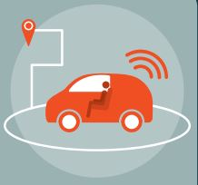
Scenario 3: Self-driving cars (autonomous vehicles)

- Use the suggested links to learn more about self-driving cars.
- Use the Analysis worksheet: ethical considerations to record your ideas.

Some new cars now come with AI assistants that help drivers. Here are two examples:
- Lane assistants help keep the car in the lane, so that it does not veer off the road to the left, or crash into other cars on the right.
- Adaptive cruise control keeps the driver’s car at a constant distance from the car in front. To enable this, the system adjusts the speed of the driver’s car as necessary.
Many new cars have cameras, radar and other sensors that provide information to an onboard AI. The AI makes decisions and then instructs the steering wheel or the brakes to carry out these decisions.
Some cars are ‘autonomous’ – can even drive themselves.
To see one of these, view the video Waymo 360° Experience: A Fully Self-Driving Journey.

