Sphero Kit
Basic Ball Control

Year level band:
F-2 (can also be adapted as an introduction activity for older students to learn the features of Sphero)
Description:​
Students are introduced to Sphero and its main features – direction, speed and colour. This lesson allows students to experiment through playing with Sphero and controlling it with the Sphero app.
Resources:
- Spheros
- iPads with the Sphero app
- Flash cards with instructions printed/written on
Prior Student Learning:
Maths: Students have done some work on navigational language (left, right, forward, backward).
Digital Technologies Summary
By the end of Year 2, students will have had opportunities to create a range of digital solutions through guided play and integrated learning, such as using robotic toys to navigate a map. Students use the concept of abstraction when defining problems, to identify the most important information, such as the significant steps involved in navigating a robot. They begin to develop their design skills by conceptualising algorithms as a sequence of steps for carrying out instructions, such as identifying steps in a process or controlling robotic devices. Students are able to use data as an input for their robotic device.
Year | Content Descriptors
F-2 | Follow and describe algorithms involving a sequence of steps, branching (decisions) and iteration (repetition) (AC9TDI2P02) .
Achievement Standards | By the end of Year 2, students design solutions to simple problems using a sequence of steps and decisions.

Element | Summary of tasks
Learning hook | Introduce Sphero and explain that we will be controlling Sphero by giving it instructions from the iPad.  You might want to have Sphero hiding in the corner – and drive it through the classroom to welcome it to the class.  Show the class how you are controlling it with the Sphero app – by dragging around the controller.  - How fast is Sphero?  - What colour are its lights?  - I can drive Sphero around on the floor – what other things do you think it can do?  Explain that students are going to spend a short time exploring Sphero and learning the controls.
Learning Map  (Sequence) | - Students can move the Sphero around using the Sphero app  - Students can change the colour of Sphero and alter its speed.  - Students can follow a sequence of instructions
Learning input | Show the Sphero app (via TV or projector if available) and highlight the main controls.  - Main controller  - Tail light – use this at the start so that the blue tail light faces you  - Colour picker  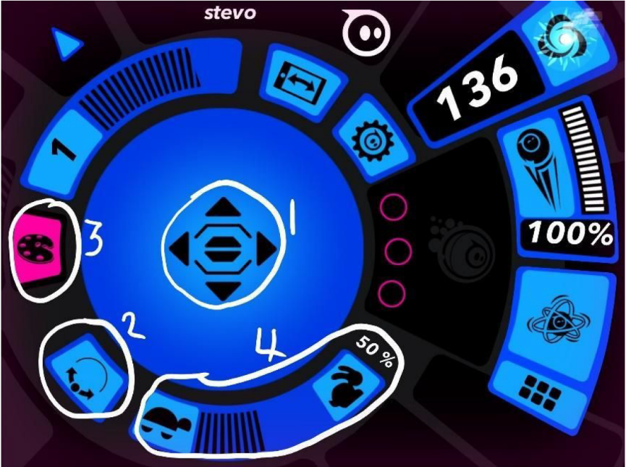  - Speed  Students spend some time getting used to the controls in small groups (three is good – one to control, one to give direction, one to retrieve the Sphero if he runs away). Each student to have a go at controlling Sphero.  Students should be familiar with the basic controls (1-4 above) but encourage them to click on other buttons and record what they discover.
Learning construction | Students create a sequence of instructions (using Flash cards) and control Sphero to follow the sequence. Have flashcards available for the class (a few of each card for each group), with commands for Sphero, e.g.  Move forward fast Move backwards slowly  Move forward slowly Move backwards fast  Change colour to red Change colour to blue  Spin round Stop  Turn to the left Turn to the right  Perhaps also have some blank cards for students to add their own instructions based on what they discovered in the Learning Input.  One student makes up a sequence using the cards, another reads it step-by-step, and another controls the Sphero to follow the instructions. Swap roles so each student can try each of the tasks.  An alternative to using the cards is having the students create a maze, e.g. drawn on paper, or physically with boxes, Lego, etc. and then navigating Sphero through the maze. See lesson plan: Sphero Maze.
Learning demo | Once students have created sequences, controlled Sphero and solved any problems, choose one sequence of cards (or have one that you have prepared) and have two or three students follow the instructions.  - Did all the Spheros do the same thing?  - What was different?  - What could we do to make the instructions more exact?
Learning reflection | Bring together the observations from the learning demo and discuss what they have learnt.  Don’t forget to show how to put Sphero to sleep!
 | 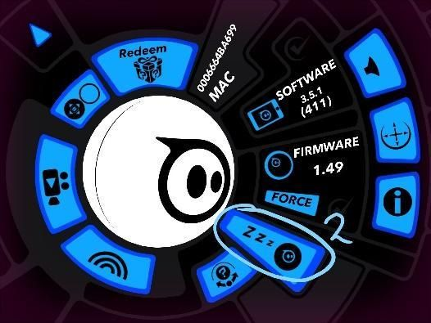  - Click the Zzz and slide the switch. | 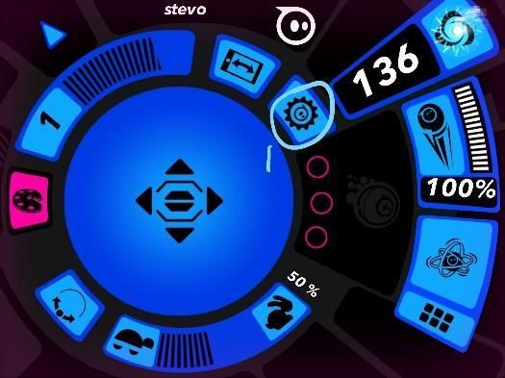  - Click the settings cog in the app.

Assessment:
Formative Assessment:
- Teachers observe students using the Spheros, controlling them and solving problems.
- Use questioning to elicit student understanding of the functions of the Sphero and how the Sphero app controls the Sphero.
- You might take photos of the students’ work to document their progress, or record the Sphero following a sequence of instructions.

 | Quantity of knowledge |  |  | Quality of understanding
Criteria | Pre-structural | Uni-struct ural | Multi-struct ural | Relational | Extended abstract
Sequences  (Algorithm) | No ​sequence followed | There are some basic instructions, but Sphero does not follow them | The sequence has a number of instructions and these are mostly followed. | Algorithm has instructions linked in the correct sequence to achieve the task​ – Sphero follows the instructions accurately | Algorithm brings in prior learning and/or independent learning beyond the task and possibly includes additional commands
Vocabulary | No specific digital technologies vocabulary is used | The terms instruction or step may be used as a general description | The terms sequence and (possibly) algorithm are used as a general description | The terms sequence and algorithm are used confidently with specific reference to learner’s work | Specific vocabulary like algorithm and debug are used, going beyond the set language

CSER Professional Learning:
This lesson plan corresponds to professional learning in the following CSER Digital Technologies MOOCs:
F-6 Digital Technologies: Foundations
- Unit 7: Algorithms and Programming

F-6 Digital Technologies: Extended
- Unit 2: Algorithms & Programming
See: ​http://csermoocs.adelaide.edu.au/moocs

Further Resources:
Sphero activities for F-2
Digital Technologies Hub: ​www.digitaltechnologieshub.edu.au
CSER: ​https://csermoocs.adelaide.edu.au
Flashcards (Word version/ PDF version)

Author: Steven Payne
This work is licensed under a Creative Commons Attribution-NonCommercial 4.0 International License​. Computer Science Education Research (CSER) Group, The University of Adelaide.

