Activity Card Overview - Teachers
Pre-preparation | Pre-print:  - Goldilocks story event cards (2X - one for the whiteboard and one for the grid)  - Bee-Bot sequence cards (for each student team)  - Map of the Bee-Bot map on grid paper for students to also look at and use for planning.  Prepare either a plastic mat with a grid for the Bee-Bot to move around and Goldilocks story cards to stick to places on the grid.
Whole Class | Place Goldilocks (or other story event) cards randomly on the whiteboard.  Students recall the story and work with the teacher to put the events into the correct sequence.  The teacher reveals the mat with Goldilocks story cards.  The teacher introduces the Bee-Bot as helping us to retell the events in the story in the correct order.  The teacher works with the students to identify the functions on the Bee-Bot (arrows, pause, go). The teacher demonstrates how to create a simple algorithm and reset.  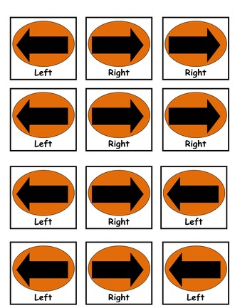  The teacher introduces the Bee-Bot arrow cards as helping to create instructions for the Bee-Bot (so we don’t forget!).  The teacher works with the students to model how to design an algorithm with the cards that will provide instructions for the Bee-Bot to get to the first story location card on the mat. Model debugging, as it arises!
Teamwork | Students work in teams of 3-4 to design an algorithm for the robot to move to the next sequence.  Students test their algorithms on the class mat and debug, as necessary.  They continue to move through as many story events as they can.
Demonstration | Students demonstrate their algorithms to the whole class, or another critical friend team.
Reflection | They discuss what happened in their algorithm and what they would do differently next time.  The teacher brings the class back together and they talk about their experiences using the Bee-Bots.
Extension | The mat can become more complex (including places that the robot has to navigate around).  Students can work in smaller teams or individually.  Students could create their own story sequence cards and instructions for another team to follow.

