Name_____________________________
My project | 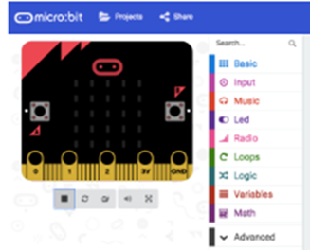

Date: __ / __ / __ | Date: __ / __ / __ | Date: __ / __ / __
What I did:  I had trouble with:  I feel | What I did:  I had trouble with:  I feel | What I did:  I had trouble with:  I feel

I can
Create a variable
Use different inputs
Use if/then
Use random value
Use maths blocks
Show LEDs
Show a string
Create a sound
Use loops

Use a sensor

My files are stored in the folder:
Digital Technologies Hub is brought to you by
Creative Commons BY 4.0 licence unless
otherwise indicated.

Australian Government Department of Education and Training
Page 1 of 2

Here is a screen capture of my program:
Digital Technologies Hub is brought to you by
Creative Commons BY 4.0 licence unless
otherwise indicated.

Australian Government Department of Education and Training
Page 2 of 2

