Student worksheet: Strings and numbers
We are learning about two data types: ‘strings’ and ‘numbers’.
Let’s start with strings.
A string is a data type used to represent a sequence of characters.
For example: ‘What is your name?’; ‘lilly#4561’; ‘$25.50’; ‘820 bus to Richmond’.
Using Scratch in step 1, we ask the user for input using the string: ‘What is your name?’
1. Write your answer in step 2 and show how it displays as a string in step 3.
1  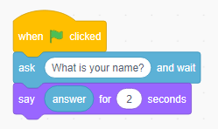 | 2  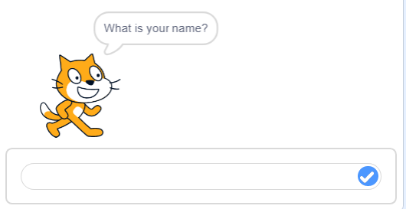 | 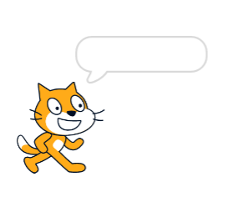  3

We can ‘join’ strings that are used in the program.
2. In this next program in step 1 below:
a) What does the cat ask? _____________________
b) What string is joined with the user input (answer) __________________
c) In step 2, write your answer to the cat’s question.
d) In step 3, write how your answer is displayed as a string.
1  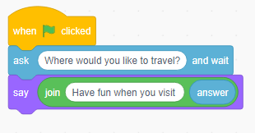 | 2  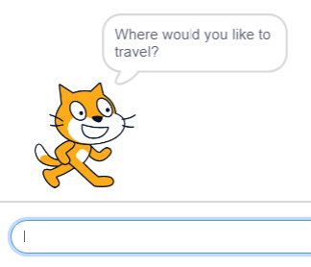 | 3

Use these boxes to show how you could use a string in a program.
1 | 2 | 3

Now let’s look at numbers.
3. In these two programs the user is asked for two numbers. Each number is stored as a variable. Next, the first number and second number are used in the program with the output displayed in the cat speech bubble.
a) What do you notice about the output (number) of each? __________________
b) What do you think the two numbers were? ________ _______
c) Look at the last line of code. What is the difference between ‘join’ and ‘+’?
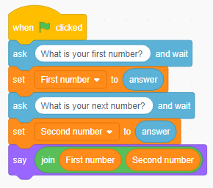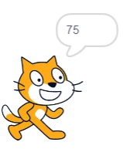 | 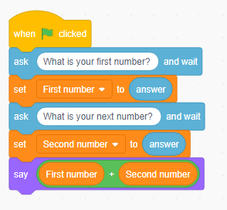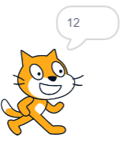

4. We can use these operators to perform calculations.
Write the mathematical operation that each block performs.
__________ __________ __________ __________

5. Look at this program. What do you think it does?

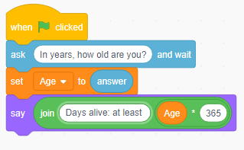 | 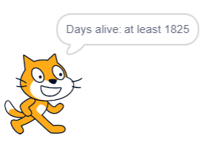
a) Explain what is happening in this program, using words such as string, variable, number, input and output.
b) What was the answer entered by the user to the question? How do you know?
c) What would be the output if you entered your age? _______

6. Think about a computer program you could create. How might you use the data type numbers and operators?

7. Reflection
Explain what you think this statement means:
‘Strings and numbers and are handled differently in programming because they are different types of information.’

