SOLO TAXONOMY

What is the SOLO Taxonomy?
SOLO Taxonomy (Structure of Observed Learning Outcomes) provides a model for different levels of understanding, including surface, deep and conceptual (Biggs and Collis 1982).

SOLO Taxonomy supports teachers to classify learning outcomes in terms of their complexity, enabling teachers to assess students’ work in terms of its quality and depth as opposed to the quantity of items achieved.

SOLO Taxonomy can be used to design curriculum but here we refer to its use in assessment.

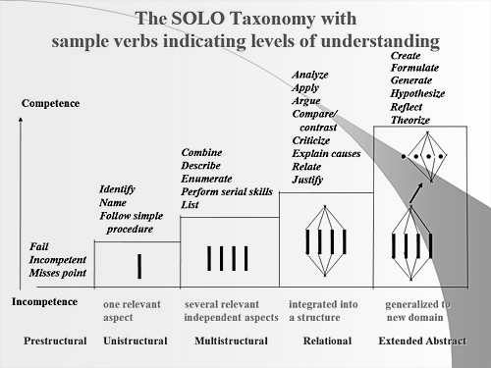
(image: http://www.johnbiggs.com.au/academic/solo-taxonomy)

HookED describe SOLO levels in the following ways:
- Prestructural:The task is inappropriately attempted. The student requires help or has misunderstood.
- Unistructural: One aspect of the task is achieved, but student understanding is disconnected and limited.
- Multistructural: Several aspects of the task are achieved but their relationships as a whole are not fully realised.
- Relational: Aspects of the task are linked and integrated and contributed to a deeper understanding as a whole.
page 1 of 3
- Extended Abstract: New understanding at the previous relational level is re-thought at another conceptual level and in a new way, and is the basis for prediction, generalisation, reflection, or creation of new understanding.

Example of SOLO Taxonomy Rubric for Digital Technologies
The Digital Technologies Hub adopts Bloom’s Taxonomy as a framework for unpacking assessment approaches by looking at the verb in achievement standards. Similarly, this same approach can be used to generate rubrics with SOLO Taxonomy.

In the example below, we have generated a rubric for the following Year 5-6 statement of achievement: “Incorporate decision-making, repetition and user interface design into their designs and implement their digital solutions, including a visual program”.

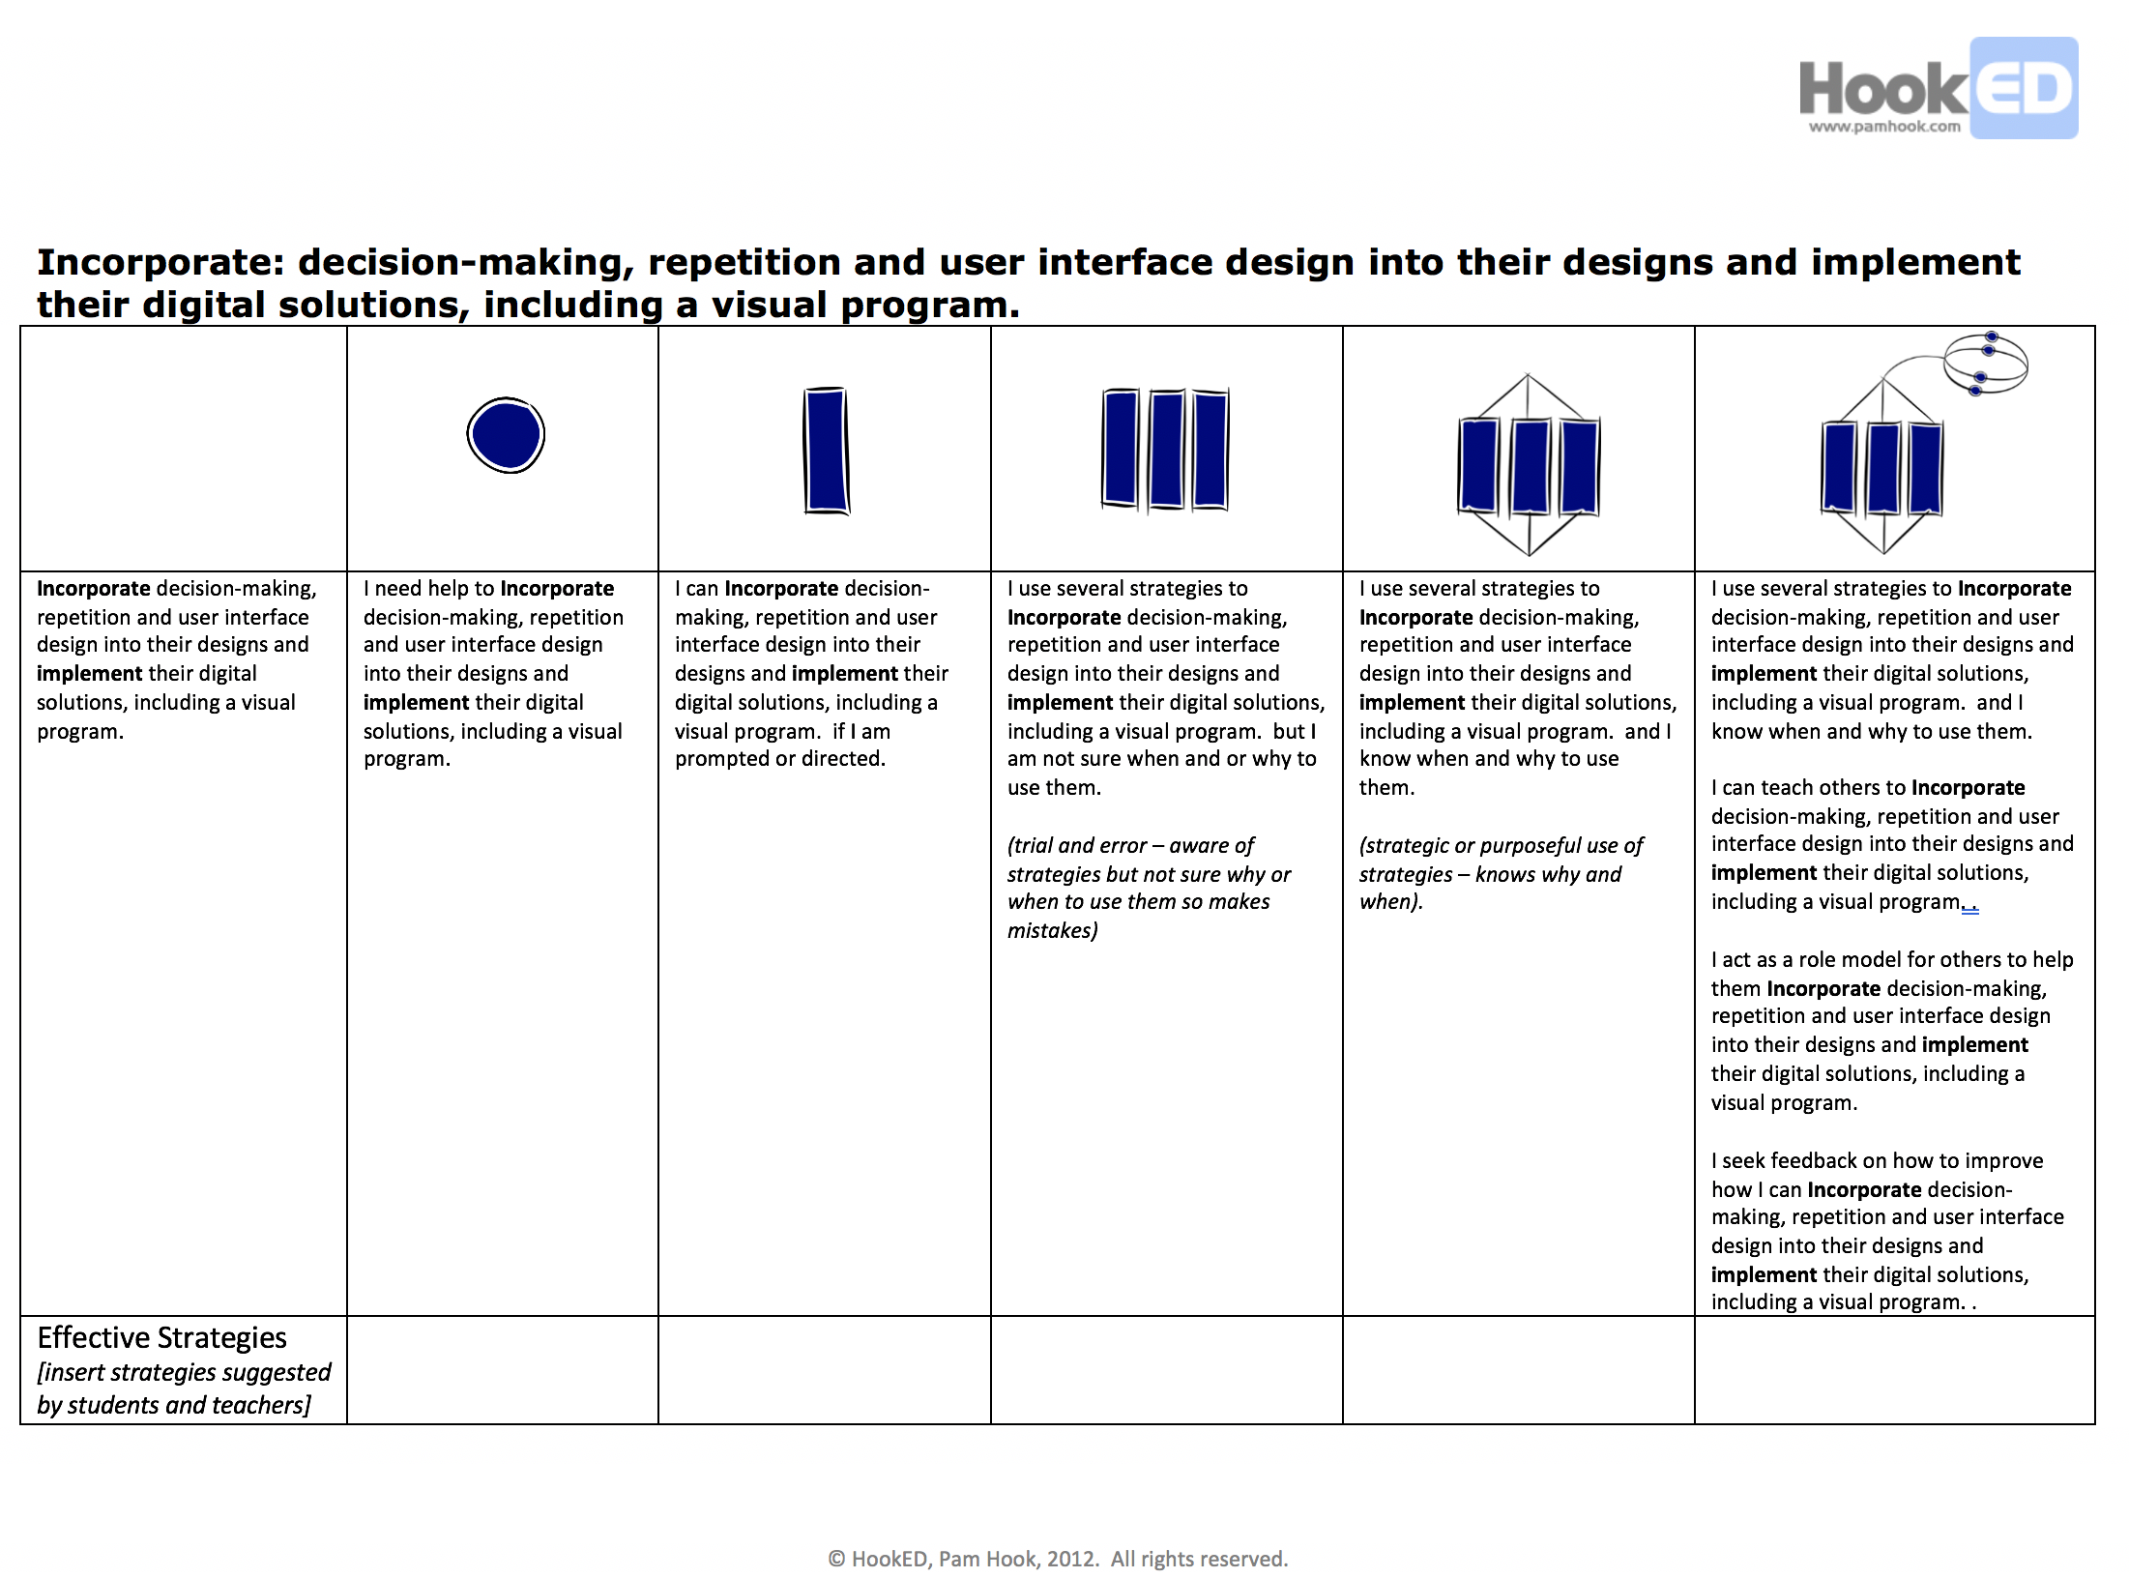

The SOLO Taxonomy Rubric could be used by teachers to assess student work or by students in self-assessment. The rubric can be a way for students and teachers to identify what levels of success look like, effective strategies that demonstrate achievement, and as a tool for providing and receiving feedback.
page 2 of 3

SOLO Taxonomy Rubric Template
Pam Hook has made available templates for teachers to download and customise (http://pamhook.com/free-resources/downloadable-resources) as well as tools that support teachers in the generation of SOLO progressions. You may choose to download and add learning goals or statements of achievement to the a document, or you might like to use the auto-generation feature provided on Pam Hook’s website, HookED (see: http://pamhook.com/solo-apps/functioning-knowledge-rubric-generator).

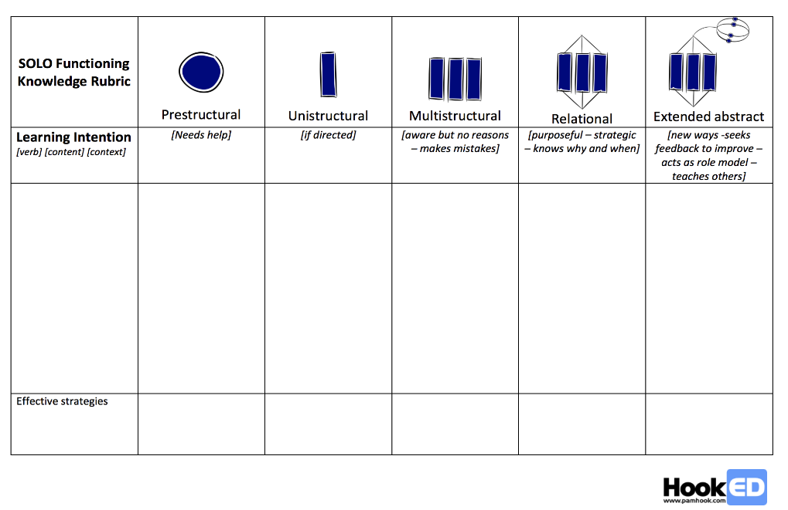
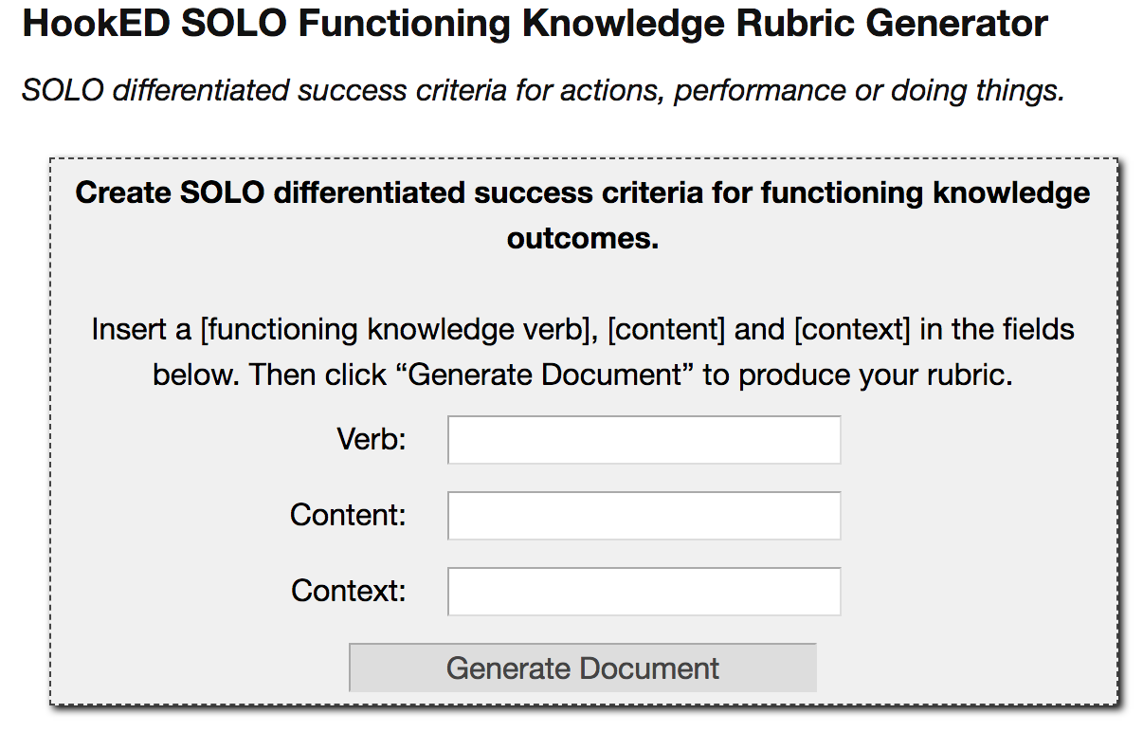
Achievement standard verb: “Incorporate” or “implement”
Remaining achievement standard description: “decision-making, repetition and user interface design into their designs...”

Resources
http://www.johnbiggs.com.au/academic/solo-taxonomy/
http://pamhook.com/
Biggs, J.B., & Collis, K.F. (1982). Evaluating the quality of learning: The SOLO taxonomy. New York: Academic Press.
page 3 of 3
Page 4 of 4

