DT + Science and Mathematics

Title: Schoolyard biodiversity detectives

Summary Text: Collect data on the biodiversity in garden beds around your school to measure the biodiversity (that is the different types of plants and animals). Explore ways to represent and present data.

This lesson was devised by Linda McIver, Australian Data Science Education Institute.

Year Level: F–2, Years 3-4

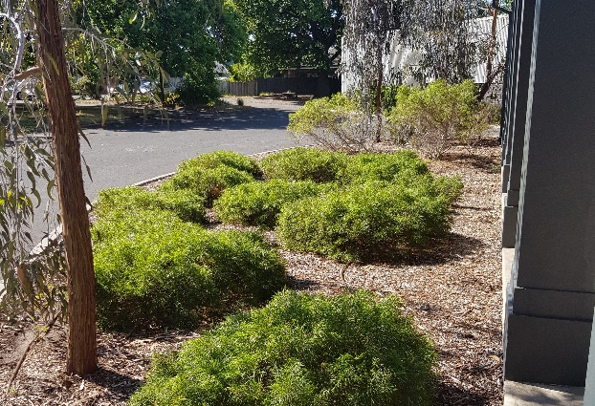

Suggested steps
- Use a suitable learning hook to engage students in the task of gathering data about schoolyard biodiversity. Ideas may include:
  - Predict what animals might be seen in the schoolyard.
  - Show images of a local bird, butterfly, bee or ‘minibeasts’ such as worms, beetles and bugs. Where might you see these animals in the school?
  - What ‘minibeast’ can you find and where will you look?
- Organise a walk around the school to take photographs of garden beds and locations where animals might be seen. (You may wish to allocate students in small groups to study and collect data on a particular area). Students could take pictures of the different plants, animals, and/or insects they see. Alternatively, students could also students construct a map with grid references and sketch what they see.
Additional scaffolding
Some students may need individual support during this activity depending on their sensory needs (sunlight), anxiety (noises), and allergies.
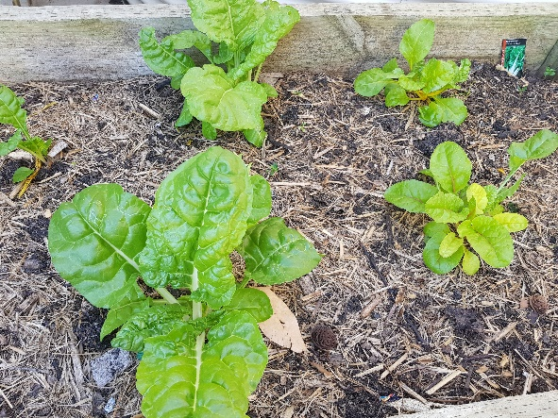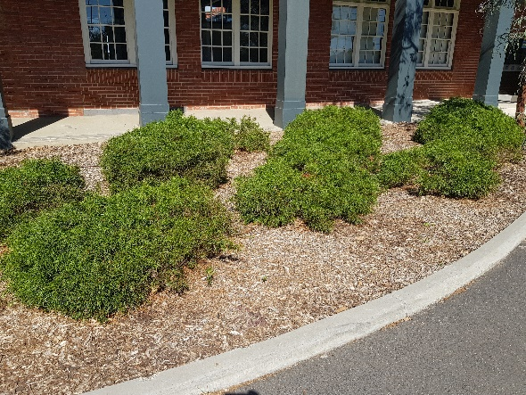
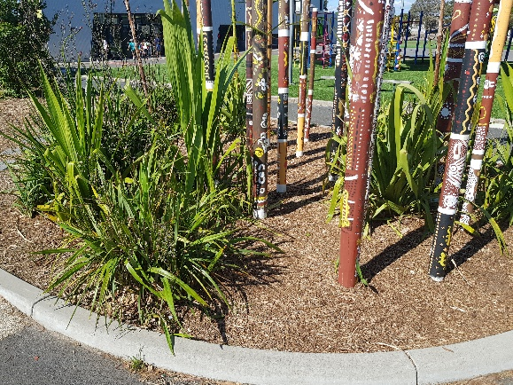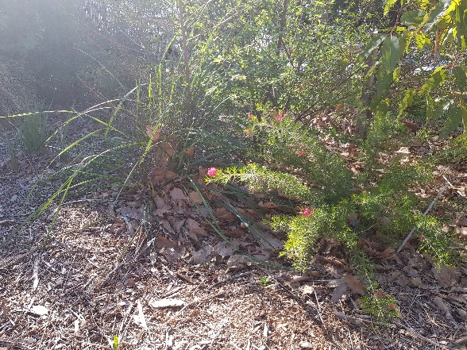
- Have students count the plants and describe them, for example 6 small bushes, 4 grassy plants, 3 trees and a large bush. Discuss ways to represent each plant. Students may draw a representation of each plant or use a coloured shape to represent different plants. As students present the information, discuss the need for title and other text that may help others ‘read’ or interpret the information.
Working memory
To simplify the task, students could just take photos outside using a camera or tablet and then back in the classroom, use those photos to do variations of the above tasks such as tallying the number of different plants they saw or the number of different colours in a photograph.
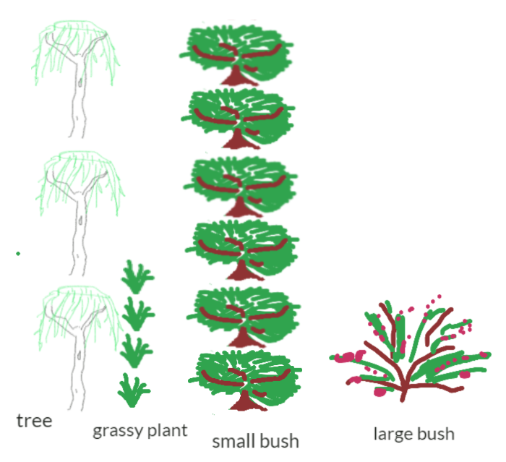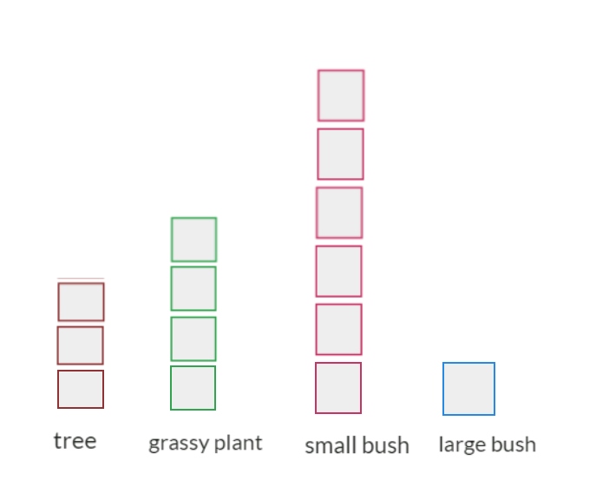
- Discuss other data that can be collected about the garden bed. Data can be recorded using images or text. An example may include data such as:
Position | Ground covering | Soil: What it looks like | Soil: How it feels | Non-living
Mostly in sun | Bark chips | Grey and sandy | Dry and dusty | Rocks and log

- Discuss ways to safely and responsibly gather data about the animals that may be found in their garden bed. Observe plant leaves and flowers for winged animals such as birds, butterflies, bees, beetles and moths. Provide an icy pole stick or similar to use to move leaf litter around or a small garden spade to dig into the soil. Students may find worms, spiders, beetles, slaters and other bugs. It may be possible to capture a digital image of the animal.
- Discuss the use of a table to record the data.
Mini-Beast | Number | Location
Bee | 5 | On plant flowers
Slaters | 6 | Under leaf litter
Brown spiders | 3 | Under leaf litter
Ants | Lots (more than 50) | Everywhere
Worms | 13 | All in soil
- Discuss ways to represent the animals observed. Before the task, ask students to show how they would digitally represent a lady bug, worm and ant. You may use software such as Paint or an app such as Explain everything. Share some examples using an interactive whiteboard or similar approach to enable class discussion. Discuss the use of colour and identifying features that would help make their representation immediately recognisable.
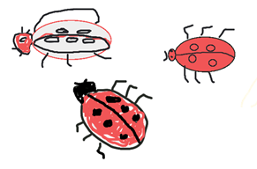 | 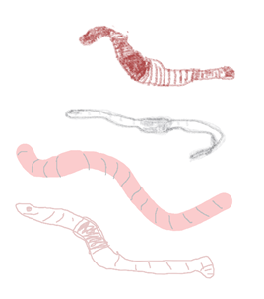 | 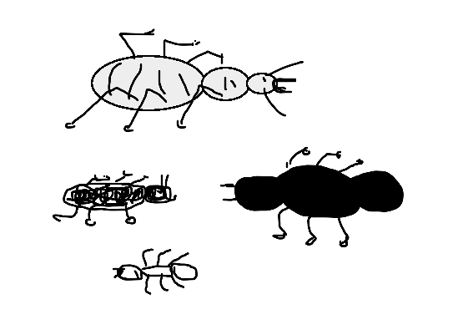

- Present the data using picture graphs or column graphs. Discuss different ways to present the information. Present and compare the group data to the class. Which garden beds have the most biodiversity?

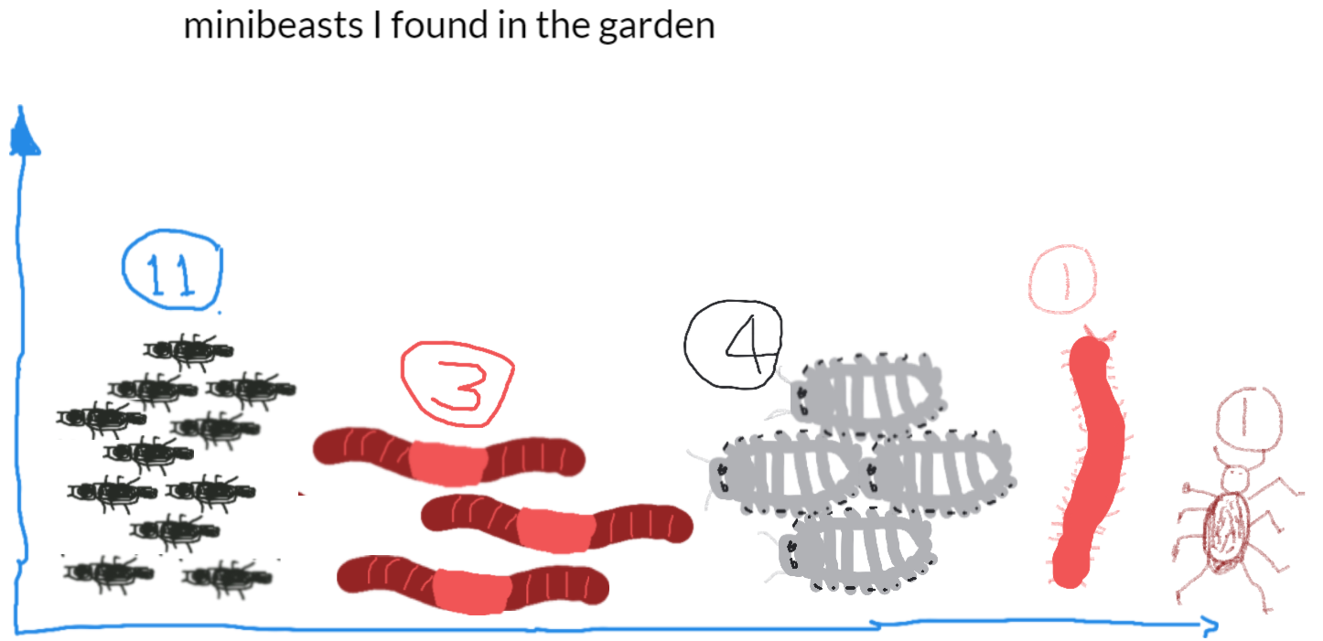
Student sample 1, using Explain everything

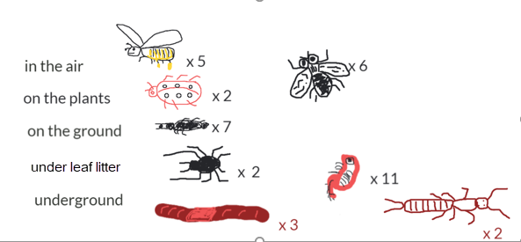
Student sample 2, using Explain everything

Discussion

Science focus
- What does the data collected tell you about your garden bed?
- What season or time of the year did you observe the garden bed? Do you expect different data if you observed at another time of the year?
- Why might more animals be found in one garden bed than another? Use the shared class data to help you answer this.
- How can we improve a garden bed that didn’t have many animals? How might you investigate this and gather data?
Digital Technology focus
- What are some ways to represent data?
- What are useful ways to present data?

Why is this relevant?
In Digital Technologies, representing data refers to the way data is symbolised, visually treated or provided in audio. For example, at this level data about animals may be represented as images of each animal, emotions may be represented as emojis, and weather data may be represented as icons for wind, rain or describing the amount of sunshine. Presentation of data deals with the format it may be presented in, such as in a table, T-chart or Y-chart, a picture graph or a bar graph.
We may collect data through observations, by survey or from other sources. Data often comes to us unorganised, so the first step is to sort the data by common characteristics or attributes; then arrange the data to help make sense and look for patterns; and finally present the data visually.
For students at Years 3-4 the focus is on how the same data can be represented in different ways. An example of this is data in a table as text can be presented as images.

Assessment

Think aloud/Student interview

Ask students to record a short video (less than one minute) to explain what their data suggests about the garden bed.

How well do students:
- Represent the data using symbols, images and text
- Present the data using a picture graph of bar graph
- Interpret the results.

Australian Curriculum Alignment

Digital Technologies

Year F-2

Representation of data

Recognise and explore patterns in data and represent data as pictures, symbols and diagrams (ACTDIK002)

Collecting, managing and analysing data

Collect, explore and sort data, and use digital systems to present the data creatively (ACTDIP003)

Years 3-4

Recognise different types of data and explore how the same data can be represented in different ways (ACTDIK008)

Collect, access and present different types of data using simple software to create information and solve problems (ACTDIP009)

Science
F-2
Science Understanding
Living things have a variety of external features (ACSSU017)
Living things live in different places where their needs are met (ACSSU211)
Science Inquiry Skills
Science involves observing, asking questions about, and describing changes in, objects and events (ACSHE021) & (ACSHE034)
Years 3-4

Living things can be grouped on the basis of observable features and can be distinguished from non-living things (ACSSU044)

Living things depend on each other and the environment to survive (ACSSU073)

Science Inquiry Skills
Science involves making predictions and describing patterns and relationships (ACSHE050) & (ACSHE061)

Mathematics
Data Representation and Interpretation
F-2
Represent data with objects and drawings where one object or drawing represents one data value.
Describe the displays (ACMSP263)

Identify a question of interest based on one categorical variable. Gather data relevant to the question (ACMSP048)

Collect, check and classify data (ACMSP049)

Create displays of data using lists, table and picture graphs and interpret them (ACMSP050)

Years 3-4
Collect data, organise into categories and create displays using lists, tables, picture graphs and simple column graphs, with and without the use of digital technologies (ACMSP069)

Interpret and compare data displays (ACMSP070)

Select and trial methods for data collection, including survey questions and recording sheets (ACMSP095)

Construct suitable data displays, with and without the use of digital technologies, from given or collected data. Include tables, column graphs and picture graphs where one picture can represent many data values (ACMSP096)

Evaluate the effectiveness of different displays in illustrating data features including variability
(ACMSP097)

ICT Capability
Typically, by the end of Year 2, students:

Collaborate, share and exchange
Use purposefully selected ICT tools safely to share and exchange information with appropriate local audiences

Select and use hardware and software
Identify and safely operate a selected range of appropriate devices, software, functions and commands when operating an ICT system and attempt to solve a problem before seeking help

