UNCLASSIFIED

Dear Students,

We are monitoring weather patterns in Australia for any variations that could be due to global warming. Global warming is affecting weather patterns, as well as our natural world on Earth including the Great Barrier Reef.

Part of our continual monitoring includes launching a large weather balloon that reaches a height of between 20-30km. During the latest weather balloon launch, the crew forgot to turn on the GoPro camera and record the weather that they observed.

We need your help to analyse the data from the launch to determine if there where clouds and if it was going to rain. The level of cloud cover will impact the radiation and temperature levels we see in the rest of the atmosphere, which are really important factors in monitoring global warming.

We appreciate your assistance in analysing the data and contributing to the overall mission success.
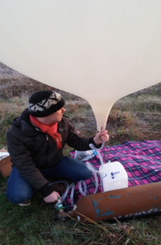

Sincerely,

The Weather People.

Launch Details
Launch Date: Tuesday 21st June 2017

Launch Site: Lake Bolac, Victoria
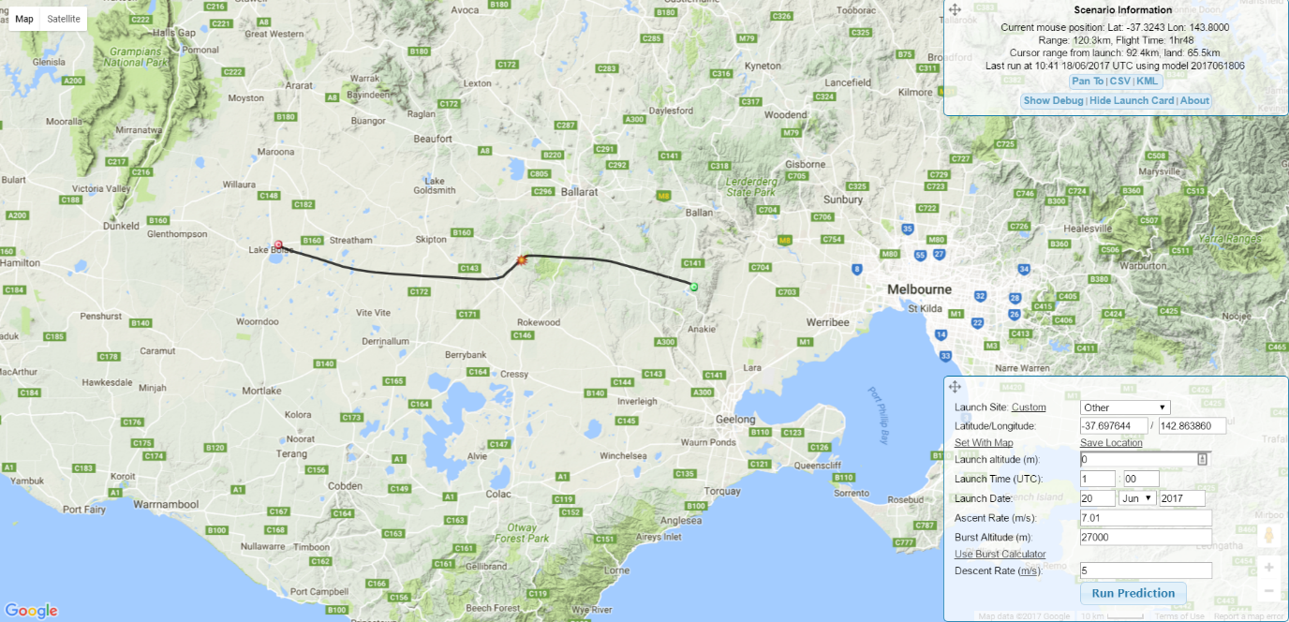

Low Altitude Wind Prediction (3 days out)
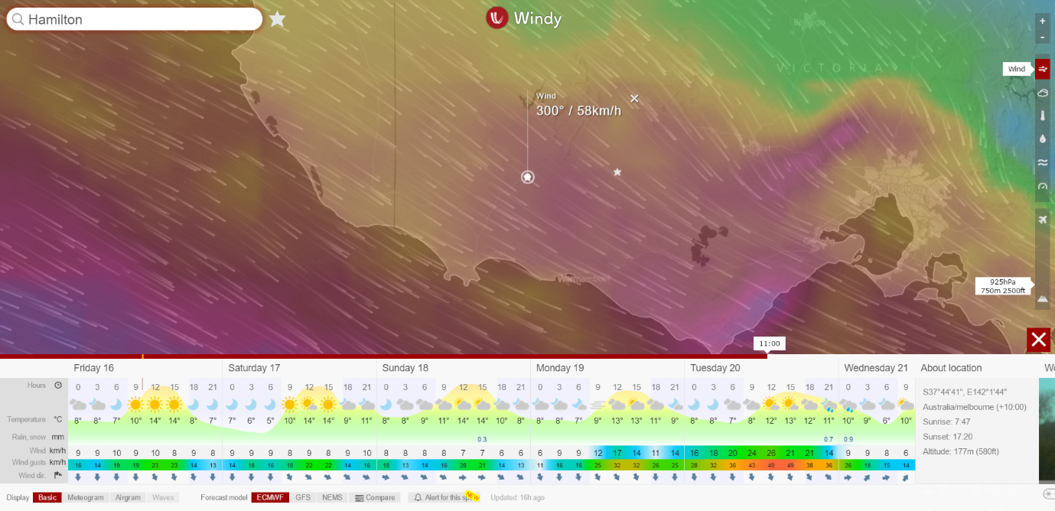

High Altitude Wind Prediction (3 days out)
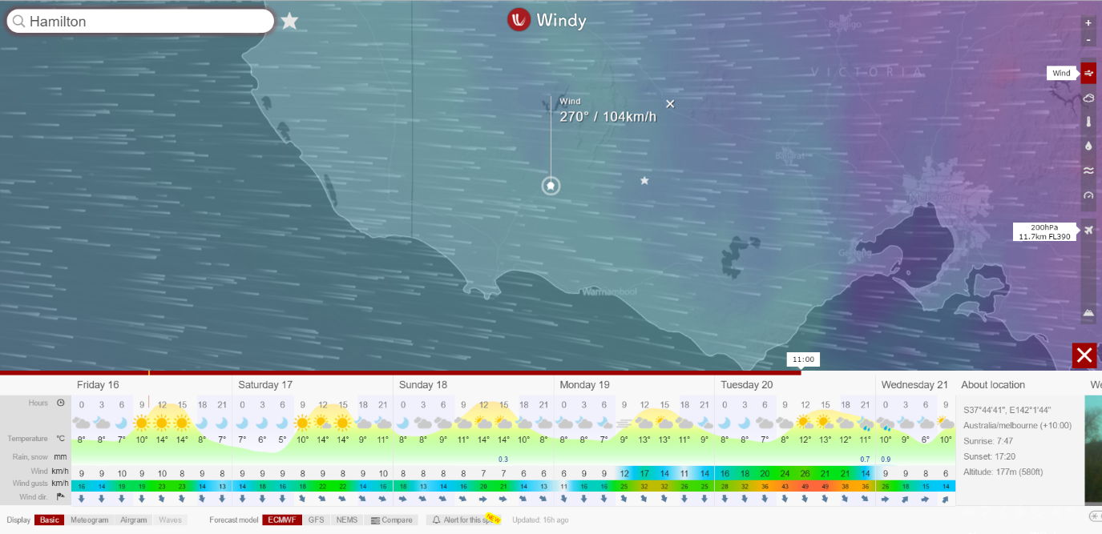

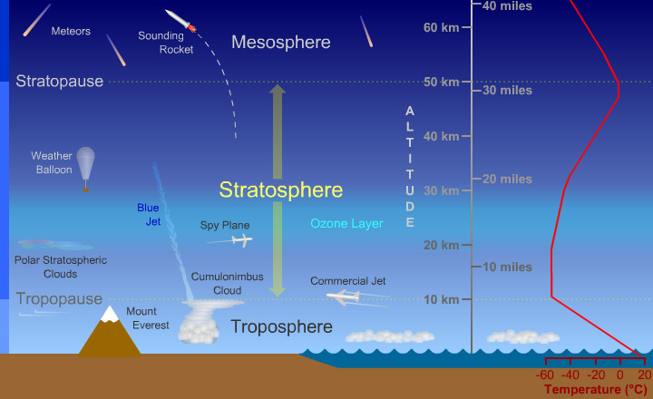
Weather Balloon Altitude Trends

