Use this document to identify barriers that impacted implementation.
A barrier is any type of challenge or constraint that can slow or halt progress on implementing the whole-school plan.
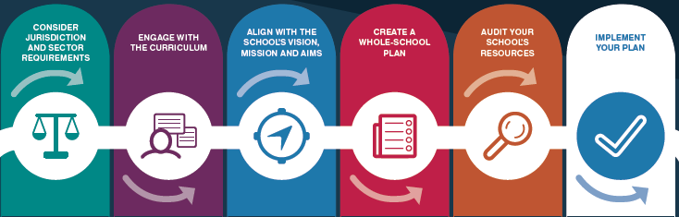
Identify barriers and suggest an approach to address and overcome the barrier. Use the examples as a guide and modify as required.

Barrier | Lack of clarity around requirements | Limited curriculum leadership of the Digital Technologies curriculum across the school | Limited time to implement due to other competing curriculum priorities | Lack of capacity within the school to document a plan | Inadequate funds to support a whole-school plan | Inconsistent implementation across the school
How to address | Organise leadership to attend jurisdiction/sector PL. | Identify teachers with capacity to lead others to undertake relevant PL. | Integrate across subject areas, raise the priority of DT. Align more strongly to reporting requirements. | Assign the curriculum leadership role to a relevant staff member to lead and drive the process. | Explore partnerships to provide cost effective programs. | Share implementation strategies across PL teams and Faculty teams.
Barrier |  |  |  |  | Limited or low understanding of the Digital Technologies curriculum
How to address |  |  |  |  | Identify teachers with capacity to lead others. Organise PL for relevant staff, support with coaching/ mentoring.

Barrier
How to address

