Choosing a predictive response
- Read each of the SMS messages.
- For each message, choose an appropriate predictive response from the options provided or modify a response to improve it.
- Give reasons for your choice.

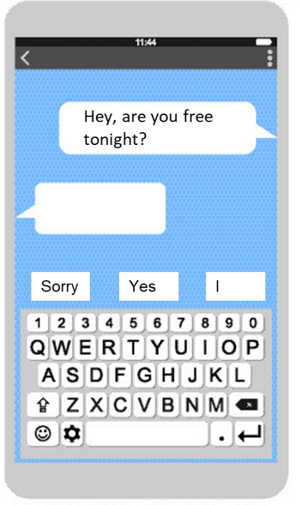
Predictive responses:

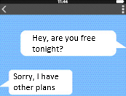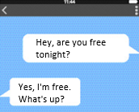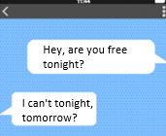

I would send: ______________________________________________________________________

My reasons: ______________________________________________________________________

Circle the important words in the SMS message:

Hey, are you free tonight?

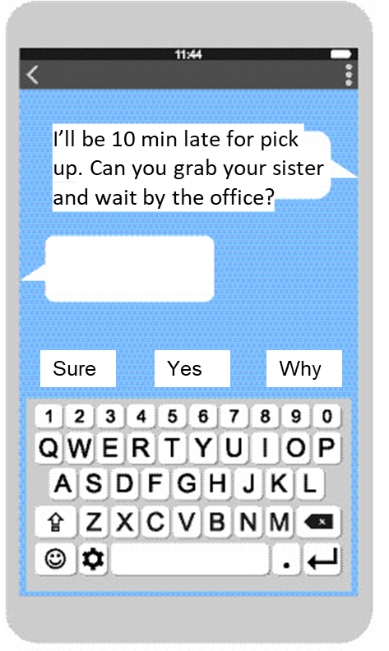

Predictive responses:

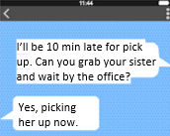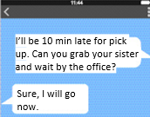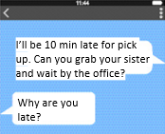

I would send: ______________________________________________________________________

My reasons: ______________________________________________________________________

Circle the important words in the SMS message:

I’ll be 10 min late for pick up. Can you grab your sister and wait by the office?

