Dynamic route planning
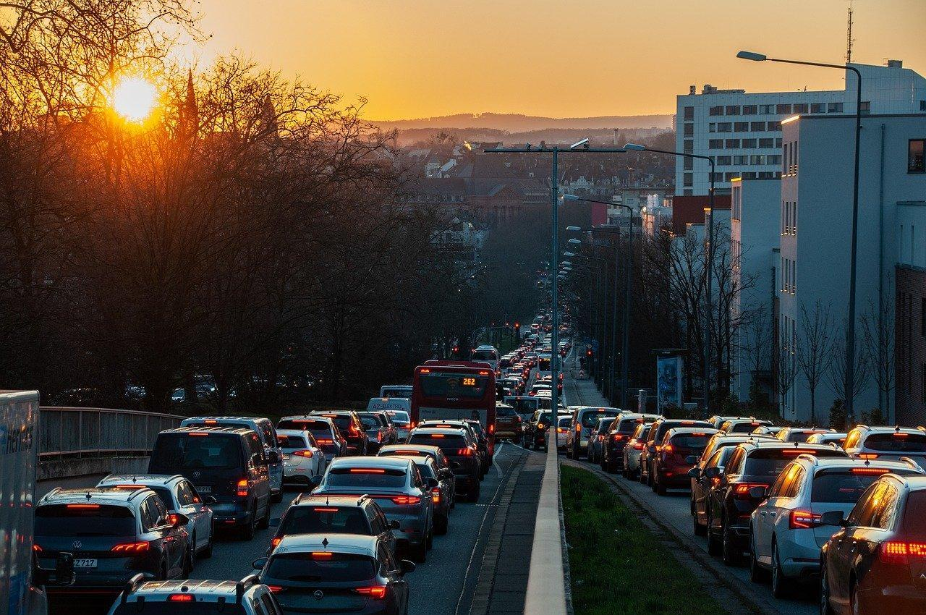
Source: Pixabay

Year levels: 9–10

Digital Technologies: Acquiring, managing and analysing data, Generating and designing

Duration: 1 x 60 min

In this learning sequence, students think critically about the types of data artificial intelligence (AI) algorithms need to analyse for real-time traffic data.

Learning map and outcomes
Learning intention
To understand how AI-powered navigation systems use real-time traffic data and historical patterns to provide dynamic route recommendations.

Success criteria
Students will be able to:
- describe the role of AI in navigation systems
- identify the types of data that AI-powered navigation systems analyse
- explain how AI adjusts route recommendations in real time based on changing traffic conditions.

Preparation and materials
- Data sources for AI in traffic analysis and answer guide [Word]
- Flowchart: AI decision for route change [Word]
- Teacher slides: Dynamic route planning

Learning hook
Introduce ways AI is used in everyday life, such as in GPS navigation systems. Show that an AI can make decisions and adjust its behaviour based on new information, similar to how humans adapt to changes in their environment.

Use the teacher slides to introduce the scenario: Imagine you are in a car with your family, and you're using a GPS navigation system to guide you to your destination. Suddenly, the GPS says 'route recalculation'. What does this mean? Why might this occur? What would you expect to happen next?

What does route recalculation mean?
- Explain that when a GPS navigation system says 'route recalculation', it means that the system is changing the route to your destination, based on new information.

Why might route recalculation occur?
- Discuss possible reasons for route recalculation, such as a change in traffic conditions, a road closure, or a missed turn.

What would you expect to happen next?
  - Encourage students to predict what the GPS might do next, such as suggesting a new route or asking the driver to make a turn to get back on track.

Learning input and construction
Encourage students to think critically about the types of data AI algorithms need to analyse for real-time traffic data and consider additional sources that could enhance the analysis process.

Introduce and discuss data sources such as:
  - traffic cameras
  - sensors embedded in roads
  - GPS devices in vehicles
  - historical traffic data
  - weather reports
  - social media posts about traffic conditions.

Provide the worksheet Data sources for AI in traffic analysis. Use the descriptions of each data source to guide discussion. An answer guide is also provided.

Students choose the data sources that they think are useful for AI algorithms to analyse real-time traffic data. They explain why they think the chosen data sources would be most beneficial. They explain how an AI system would work, indicating the role data plays in the system.

Differentiation
Allow students to choose data sources that match their understanding level.
Provide guiding questions for students who need extra support. For example:
  - Why do you think this data source is important for AI in traffic analysis?
  - How might this data source help AI make more accurate predictions?

Learning demo
Create a flowchart to illustrate how an AI makes a decision about a new route based on an accident further ahead.

Explain that flowcharts are visual representations of a process, showing the steps involved and the decision points along the way. Use the Summary of flowchart symbols slide to discuss the process.

Introduce the scenario: Imagine you are designing an AI system for a navigation app. The AI needs to decide whether to reroute a driver who is approaching an accident further ahead. How would you represent this decision-making process in a flowchart?

Ask students to create a simple flowchart that illustrates the decision-making process of an AI-powered navigation system when determining whether to change a route due to an accident ahead. The system should evaluate traffic conditions, check for alternative routes, calculate the optimal route based on various factors, and communicate the route change to the user. A key aspect is for the AI to weigh conflicting objectives, for example, a detour is longer but can have a shorter travel time. The AI needs to consider the user’s preferences.

Differentiation (support)
- Provide students with a ready-made Flowchart: AI decision for route change and ask them to follow and interpret the flowchart.
- Provide a flowchart example with sections covered up by post-it notes and ask students what the covered-up section might be.
- Provide students with step headings to guide and scaffold the process.

Differentiation (extension)
- Students create their own flowchart using the requirements as a guide.

Reflection
Pose the questions:
- How do real-time traffic data and historical patterns influence route recommendations?
- In what ways do you think AI could further improve navigation systems in the future?

Why is this relevant?

Dynamic route planning: AI-powered navigation systems use real-time traffic data and historical patterns to provide users with dynamic route recommendations that avoid congestion and reduce travel time. These systems can also consider factors like road closures, accidents and construction sites to offer the most efficient routes.

Assessment
Achievement standard
By the end of Year 10, students acquire, interpret and model complex data. They design and validate algorithms.
Note: indicates only the relevant elements of the achievement standard.

Australian Curriculum alignment
Technologies – Digital Technologies

Generating and designing

Design algorithms involving logical operators and represent them as flowcharts and pseudocode AC9TDI10P05

Acquiring, managing and analysing data

Analyse and visualise data interactively using a range of software, including spreadsheets and databases, to draw conclusions and make predictions by identifying trends and outliers AC9TDI10P02

Resources
- Sheet: Data sources for AI in traffic analysis and answer guide
- Sheet: Flowchart: AI decision for route change
- Teacher slides: Dynamic route planning
- Slide: Summary of flowchart symbols

