Data sources for AI in traffic analysis
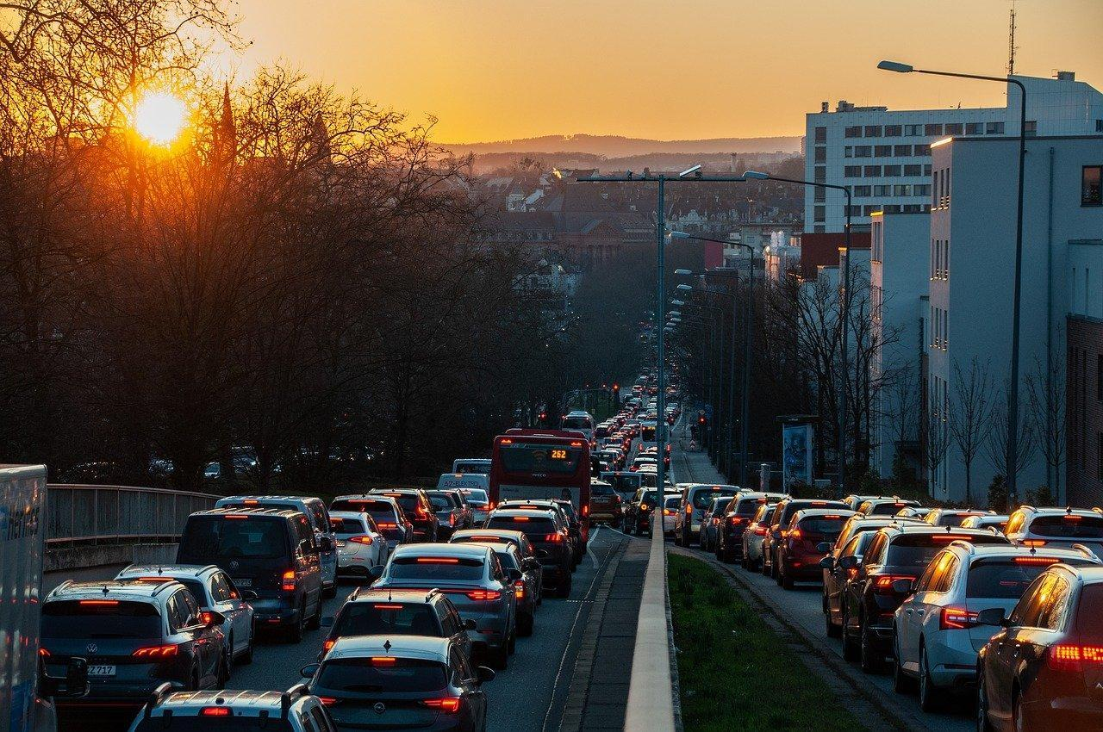
Source: https://pixabay.com/photos/traffic-city-traffic-jam-cars-7859033/
Review the list of data sources provided below.
- Choose data sources that you think are useful for AI algorithms to analyse real-time traffic data.
- Describe ways the AI could use each dataset.
- Explain how your AI system will work.
Traffic cameras: provide real-time visual information about traffic conditions, such as congestion, accidents, and road closures.
Sensors embedded in roads: can detect vehicle presence, speed, and traffic flow.
GPS devices in vehicles: provide location information for vehicles that can be used to track their movements.
Historical traffic data: provides long-term traffic data related to traffic flow and volume.
Social media posts: can provide real-time data about road accidents and traffic incidents.
Weather information: can provide latest weather conditions.

