Draw and write what you recall from the story, On the way to Nana’s.

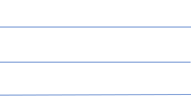

Cut out and order these parts from the story, On the way to Nana’s.
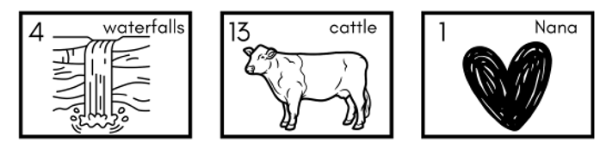
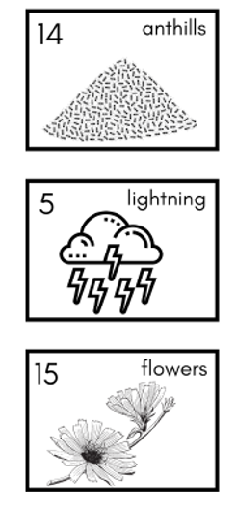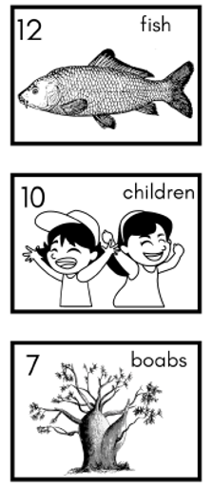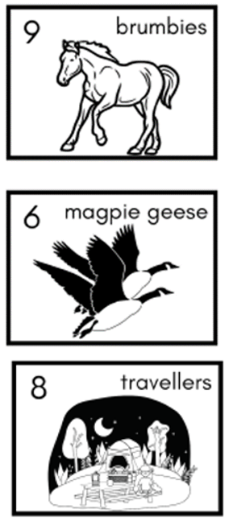
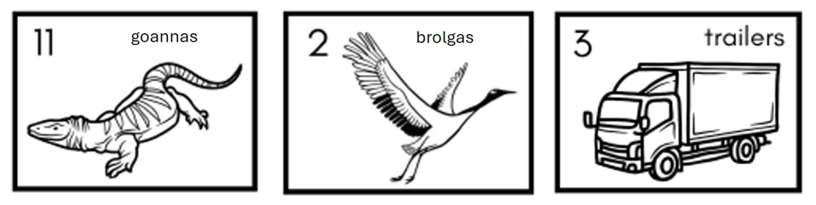

Cut out and order these parts of the story.

Twelve fat fish and the  long road ahead of me | Fourteen rugged anthills and the long road ahead of me
Eleven alert goannas and the  long road ahead of me | Eight weary travellers and the long road ahead of me
Five flashes of lightning and the long road ahead of me | Six flying magpie geese and the long road ahead of me
Two dancing brolgas and the long road ahead of me | One excited Nana and the long road ahead of me
Three dusty trailers and the long road ahead of me | Seven bulging boabs and the long road ahead of me
Four flowing waterfalls and the long road ahead of me | Fifteen colourful flowers and the long road ahead of me
Nine proud brumbies and the long road ahead of me | Ten happy children and the  long road ahead of me
Thirteen grazing cattle and the long road ahead of me

