New subject at Year 10

Fiona Clayton is eLearning Coordinator at Torrens Valley Christian School (TVCS). She describes how their new Year 10 Digital Technologies subject has had an impact both on current students and on numbers opting to go on and study in this area in Years 11 and 12.

As a result of introducing this new Digital Technology subject at Year 10 (and the teaching of programming at Year 9) we are seeing the skill set of students increasing each year so much so that this year the Year 10s are learning what the Year 11s did last year and the Year 11s are able to learn what was taught at Year 12.

Read on for the Unit Overviews, samples of assignments and tips for implementation.

Our focus
Introduction of programming in the new Year 10 Digital Technologies subject
Before I started at TVCS, the subject ‘Computing’ was an elective at Years 9 and 10. It involved touch-typing and using Word and Excel. Students had very little programming knowledge (some had used Scratch in primary school). In 2015 we removed Computing from the Year 10 curriculum and replaced it with two new electives, Digital Technologies and Multimedia Studies. Multimedia Studies focuses on the ‘soft tech’ of graphic design, video production, website creation and assisting with all aspects of the school musical production. Digital Technologies focuses on programming and getting students interested in Information Technology.
Digital Technologies is taught in both semesters and covers the following topics:
- Flash ActionScript for game development
- Introduction to networks
- Website programming using HTML/CSS/JavaScript
- Java programming and pseudocode

Digital Technologies: Semester 1 overview
Digital Technologies: Semester 2 overview
In the first year this was taught, we had a class of 11 students in semester 1 and 12 in semester 2. This grew to 19 students in semester 1 last year and 16 in semester 2. We have similar numbers this year.
We found that students, particularly boys, who struggled to find other elective subjects they enjoyed, were engaged and were quickly able to grasp the basic programming concepts. They learnt key problem-solving skills, which they could then apply to their other subjects.
The biggest impact that we noticed was for those quiet, shy, students who normally don’t say much in the classroom. Suddenly, they came out of their shell and became leaders in the class, helping other students, answering questions and were eager to get ahead and have extension work.
It was these students that continued and went on to complete the South Australian Certificate of Education (SACE) Stage 1 IT last year and are doing SACE Stage 2 IT this year.
Important factors
Introducing these new subjects was fundamental in the shift we have seen in our school towards embracing digital technologies. It was the starting point for what was to come. However, it could not have been done without the support of the principal, the school board, and the IT staff (non-teaching). The school put a lot of money towards upgrading computers in the labs and purchasing the latest Adobe Suite of programs including Flash and DreamWeaver.
Another critical factor to this being a success was to make the learning fun and engaging. We started off by having the students program games – something that is visually appealing and fun – rather than programming using a command line.
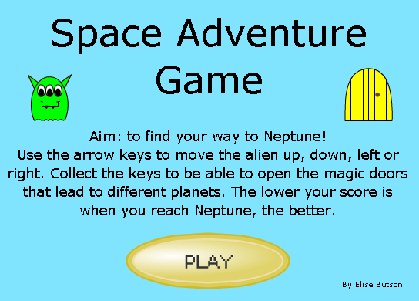
Sample teaching materials include:
- Adventure game assignment
- Collaboration assignment
- Introduction to ActionScript 3
- Variables
- Coding buttons
As a result of introducing this new Digital Technology subject at Year 10 (and teaching programming at Year 9), we are seeing the skill set of students increasing each year, so much so that this year the Year 10s are learning what the Year 11s did last year and the Year 11s are able to learn what was taught at Year 12. We hope that this can only improve their results at the end of Stage 2.
Next steps
Because of this increase in knowledge and understanding coming through the younger years, we are currently looking at ways to bridge the gap between Scratch programming and what we teach in Year 10. The possibility is to move the Year 10 course down to Year 9 and then introduce GameMaker or Godot Engine to create more sophisticated games in Year 10. Or we could focus on Python programming.
We have also started a Girls Only Code Club <link to this resource – it is another in this series> for middle school students, with senior school students coming in to mentor. We even have a teacher and an IT support staff member joining us to increase their own knowledge of coding. We are hoping to encourage more girls to continue with IT in Years 11 and 12 and to have at least one, if not more, girls in our Year 12 class for the first time next year!
Key resources
The update of resources included:
- the upgrade of the computers in the computer labs to support the Adobe CC suite of programs
- the purchase of the Adobe CC suite of programs
- offering two new digital technologies subjects at Year 10 with timetabling that enabled students to choose both subjects.

Useful online resource/link
ORB Education resource: Algorithms & Programming Yrs 9–10

Tips and advice
Tips for other schools wishing to undertake a similar project activity
Don’t be afraid to jump in and give it a go. It’s OK if the students know more than you do, they love showing you what they have learnt and will often find better ways of doing it than you do. Reach out to colleagues for advice and support.

About our school
About Torrens Valley Christian School
Torrens Valley Christian School is an F–12 school located in the north-eastern suburbs of Adelaide, South Australia. We currently have around 650 students.
In 2015, the school appointed an eLearning Coordinator for Years 7–12 (as well as two for the primary school, one coordinator for Reception – Year 2 and another for Years 3–6). The vision for this role was to improve the eLearning at the school in regards to infrastructure (working with the IT Manager and IT staff) and use of 1:1 devices, and to introduce curriculum changes including implementing the Digital Technologies curriculum and associated staff development.
Since then the school has seen the introduction of the following:
- an upgrade of the wireless infrastructure
- an upgrade of the 1:1 devices for Senior School: Microsoft Surface tablets for Years 10–12
- three laptop trolleys available for Middle School students (Years 7–9)
- access to Office 365 and OneDrive and therefore the use of OneNote Class Notebook
- provision of SACE Stage 1 and 2 Information Technology classes (Years 11 and 12)
- implementation of the Digital Technologies curriculum (R–10)
- introduction of robotics, including being involved with the FIRST Lego League competition
- use of Raspberry Pi hardware
- teaching of programming in multiple languages
- introduction of Girls Only Code Club <hyperlink to this content>
- introduction of Robotics Club. <hyperlink to this content>

