Sphero: Catch me if you can

Year level band:​ 5-6
In this lesson students will use Sphero to explore Bluetooth connectivity, algorithms through maze mapping and visual programming language.
Description:​ ​Resources:
- Sphero robot
- Tickle software app for iOS and Android devices
- Sphero Curriculum available online
- Introductory video of the Sphero and Meet Sphero
- Building and construction materials such as Knex or Lego
- Sphero Apps including
  - SPRK Lightning Lab ­ Programming for Sphero Robots by Orbotix Inc. (Sprk+)
  - Sphero by Sphero Inc. (Sprk+)
  - Sphero Exile by Sphero, Inc.
  - Sphero ColorGrab by Sphero Inc.
  - Sphero Edu by Sphero Inc.
Prior Student Learning:
By years 5 and 6 many students may have had some experience with a visual programming language such as Scratch or Blockly that is the basis of the Hour of Code.
Sphero will take the screen based control of an image to the next level by introducing a robotic device controlled by a visual programming language.
If your students are new to visual programming languages there are a number of excellent resources they might try to help them become familiar with computational thinking tasks. The Hour of Code is a good place to start.

Digital Technologies Summary
By the end of Year 6, students will have had opportunities to create a range of digital solutions, such as games or quizzes and interactive stories and animations. For example controlling a robotic device to follow a set of instructions.
Students increase the sophistication of their algorithms by identifying repetition and incorporate repeat instructions or structures when implementing their solutions through visual programming, such as reading user input until an answer is guessed correctly in a quiz. They evaluate their solutions and examine the sustainability of their own and existing information systems.
The use of robots such as Sphero provide students with an opportunity to work collaboratively with their peers to solve problems such as following a maze through the programming of step by step instructions.
Band | Content Descriptors
5 - 6 | Design algorithms involving multiple alternatives (branching) and iteration (AC9TDI6P02) .  Implement algorithms as visual programs involving control structures, variables and input (AC9TDI6P05) .
The particular elements of Critical and Creative Thinking addressed by this content description:
- Inquiring – identifying, exploring and organising information and ideas
  - Identify and clarify information and ideas
  - Organise and process information
- Generating ideas, possibilities and actions
  - Consider alternatives
  - Seek solutions and put ideas into action
- Analysing, synthesising and evaluating reasoning and procedures
  - Apply logic and reasoning
Achievement  Standards | By the end of Year 6, students will have had opportunities to create a range of digital solutions, such as games or quizzes and interactive stories and animations.

Element | Summary of tasks
Learning hook | Sphero is wanting to find his/her friend who has become stuck in a tight spot in a corner of the classroom and cannot find a path out through the maze of objects scattered on the path.  What set of instructions could you give Sphero to help navigate to his/her friend and then help them both to return?  Alternatively, students may wish to explore a particular seafarer or land explore from the past by drawing a large stylised map on the school playground and have Sphero take on the role of Captain Cook of Burke and Wills for example.  What adventures might he/she have on his/her voyage? This could work in nicely with a history or geography lesson on significant historical figures navigating parts of a geographical landscape.
Learning Map  (Sequence) | - Students work together to plan a solution to a problem  - Students create a series of instructions (Algorithms) with alternative solutions should one plan fail.  - Students connect to robot using bluetooth device to send instructions.  - Students test visual program algorithm and debug until successful.  - Students create a game that could be shared with their peers. Instructions could be written for the game that others could use to learn how to play the game.
Learning input | The teacher introduces the Sphero or Spheros to the class and asks them what they think it might be.  After a number of responses and the eventual answer being a robot that can be controlled by a digital device, have the students discuss how Sphero can be sent instructions.  Allow time for discussion on Bluetooth and comparisons to Wireless. Discuss wireless, bluetooth and connected networks.  Introduce or elaborate on visual programming languages and the importance of clear instructructions (Algorithms) when controlling Sphero and setting tasks.
Learning construction | Using the Tickle app for iPad or Android devices make a connection to Sphero and explore the visual programming language in Tickle.  Send instructions to Sphero to follow.  Students, once they are comfortable with the visual programming language, might set up paths using masking tape or objects for Sphero to negotiate.  Have students work in teams to solve a number of challenges.  Use the Sphero Edu app to program Sphero to roll in the shape of various polygons. See more information here.  To introduce the lesson, the teacher briefly revise the concept of a ‘regular’ shape and the language used to describe polygons Greek prefixes for numbers.  Students worked in teams of about five to follow step-by-step instructions to ‘draw’ Square and Triangle, then Extension to create obscure paths using learned skills.  The Sphero Edu app for iPad or Android has a series of tutorials that explains how to change the colour and/ or direction and/or speed of Sphero along with a range of other commands.  Create a maze, or obstacle course and then program Sphero to navigate the course (see Maze Mayhem). Opportunity for team learning in the areas of measurement, problem solving, and programing using Sphero Edu app.  Plan and implementing a solution using a visual programming language, for example designing and creating a simple computer game involving decisions and repetitions, suitable for younger children, that requires user input to make selections, taking into account user responses.
Learning demo | Introduce some of the apps available for Sphero on an iOS or Android device. How might Sphero Exile or Sphero ColorGrab be used in the classroom to encourage problem solving?  Can the students adjust the speed of Sphero and its direction?  What games could the students create of their own?
Learning reflection | Students could look at the limitations and advantages of a spherical robot. Could such a robot be used for supporting rescue missions or exploring unfamiliar environments?  What sort of features can students think of to enhance Sphero’s capabilities?  Are students able to explain in plain English their instructions (algorithms) to others and carry out testing of algorithm to check for bugs. Can they then debug their algorithm if problems are found?  Were the students engaged and prepared to solve the problems they came up against when creating an algorithm for Sphero to complete the challenge presented?

Assessment:
Formative Assessment
- Observe students' initial engagement with Sphero
- Review their ability to determine how Sphero can receive instructions via Blluetooth
- Observe engagement and understanding of visual programming language using Tickle or MacroLab apps.
- Demonstrate understanding of use of visual programming language within and app to control a wireless or bluetooth device.

 | Quantity of knowledge |  |  | Quality of understanding
Criteria | Pre-structural | Uni-struct ural | Multi-struct ural | Relational | Extended abstract
Algorithms  Programming | No visual program written within app interface. | Algorithm only shows a limited number of instructions but do not allow Sphero to progress or connect. | Algorithm has enough instructions to complete the task but not linked to Sphero | Algorithm has instructions  linked in the correct sequence to achieve the task​ – Sphero can follow a path as designed | Algorithm brings in prior learning and/or independent learning beyond the task and possibly includes additional blocks and features (e.g. loops)  Full use of  Programming  interface is evident
Vocabulary | When  describing algorithm, no specific vocabulary is used | The terms instruction or code may be used as a general description | The term algorithm is used as a general description | The terms algorithm and program is used confidently with specific reference to learner’s work | Specific vocabulary like decisions and repetition is used, going beyond the  set language

Teacher/Student Instructions:
The Sphero robot is a versatile device in many ways, however it does not have sensors like some other robots for example Meet Edison or Dash and Dot. In saying that, there is still much that can be done with the Sphero within a visual programming framework using the Tickle app and or Sphero Edu app.
Bluetooth connectivity can be tricky at times, particularly with a number of other bluetooth devices in the same vicinity. Be sure to leave space enough for students to connect to the right Sphero.
CSER Professional Learning:
This lesson plan corresponds to professional learning in the following CSER Digital Technologies MOOCs:
F-6 Digital Technologies: Foundations
- Unit 7: Algorithms and Programming
- Unit 8: Visual Programming
F-6 Digital Technologies: Extended
- Unit 2: Algorithms & Programming
See: ​http://csermoocs.adelaide.edu.au/moocs
Further Resources:
There are many Sphero apps now available to explore with your students on the iPad, more being added over time. Here are some of the ones you might explore with your students.
  - SPRK Lightning Lab ­ Programming for Sphero Robots by Orbotix Inc. (Sprk+)
  - Sphero by Sphero Inc. (Sprk+)
  - Sphero Exile by Sphero, Inc.
  - Sphero ColorGrab by Sphero Inc.
  - Sphero Edu by Sphero Inc.
Digital Technologies Hub: www.digitaltechnologieshub.edu.au​
CSER: https://csermoocs.adelaide.edu.au​
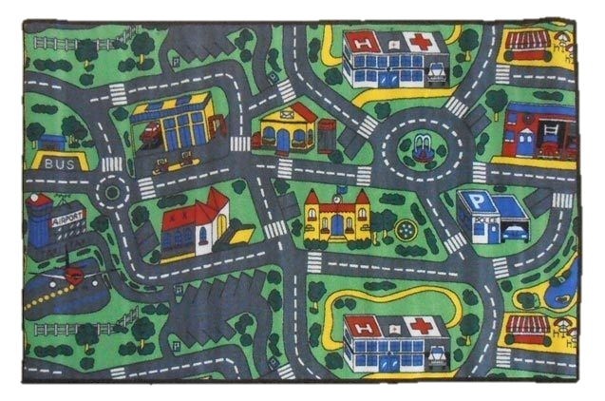
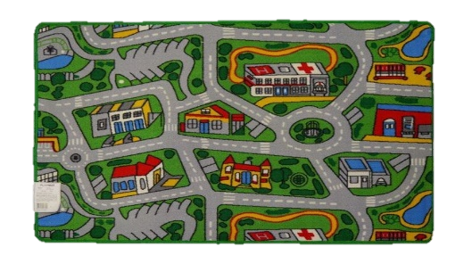
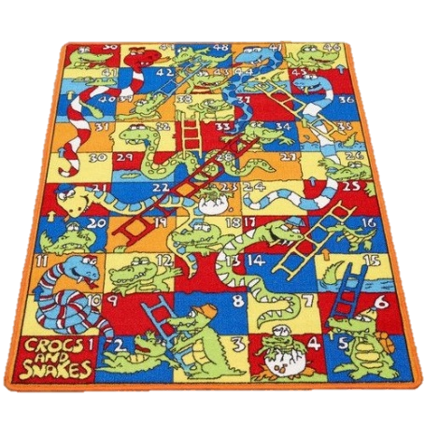
Spotlight and other stores sell street map carpets for under $50 which might work well for setting instructions for Sphero.
Also available are mats for Snakes and Ladders which might be suitable for Bee Bots if introducing algorithms for the first time.

