Excel Analysis Worksheet
The following instructions are the analysis of the stratosphere humidity data using Excel 2016. If you require instructions for other versions of Excel, please refer to this website to find your particular version.

Step 1
Open the Excel files of data collection, all the data should have been automatically input into Excel like in the figures below.
Column A contains a timestamp called “UNIX”. This is a particular way of stating time. The corresponding time is found in Colum B. For the sake of simplicity, will use Colum B for our analysis.
Humidity data is found in Colum C. Humidity is measured as a %.
Temperature is found in Colum D and is recorded in Degrees Celsius.
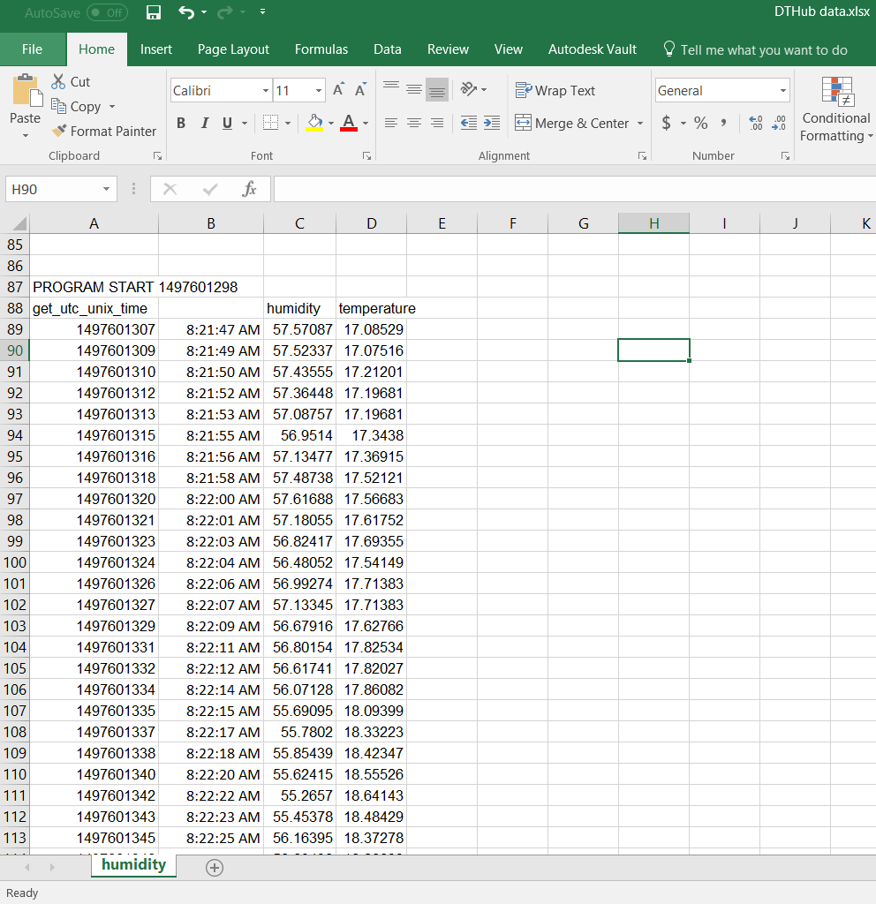
Step 2
Graphing data enables us to easily understand what is happening and is useful for comparing how something changes over time.
In this case, we want to see how humidity and temperature change over time, so we can see if there are any distinctive moments during the weather balloons journey.
The most useful plot for us in this circumstance is a scatter chart. Take the time to experiment and explore other graph types available in excel. Each type of graph represents data differently and are useful for different data sets.
Click Insert > Charts > Insert Scatter or Bubble Chart

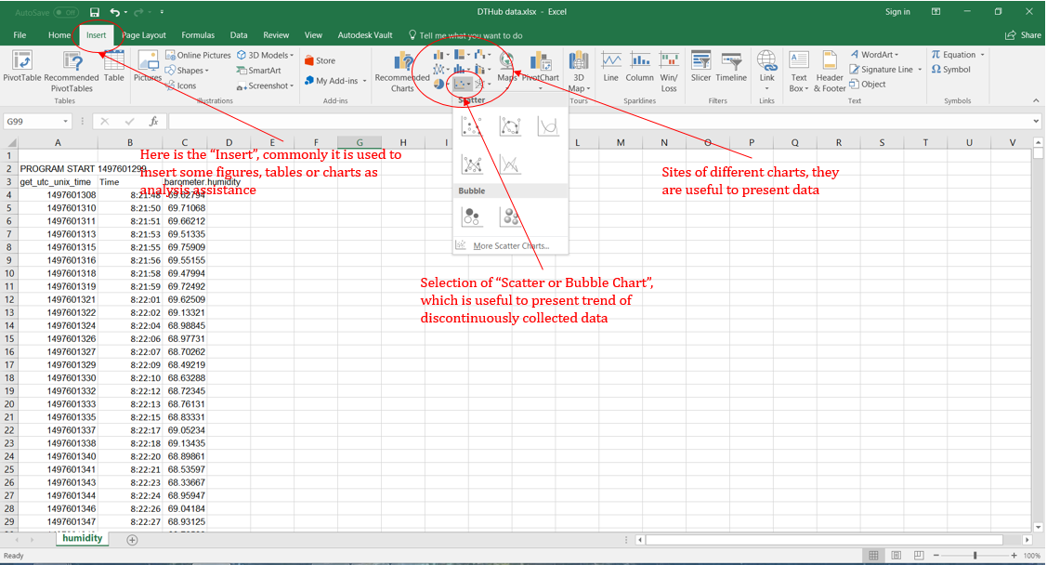

Step 3
There are different kinds of scatter and bubble charts. In this case, it is recommended to use the “Scatter with Smooth Lines and Markers” as our data has a general trend.

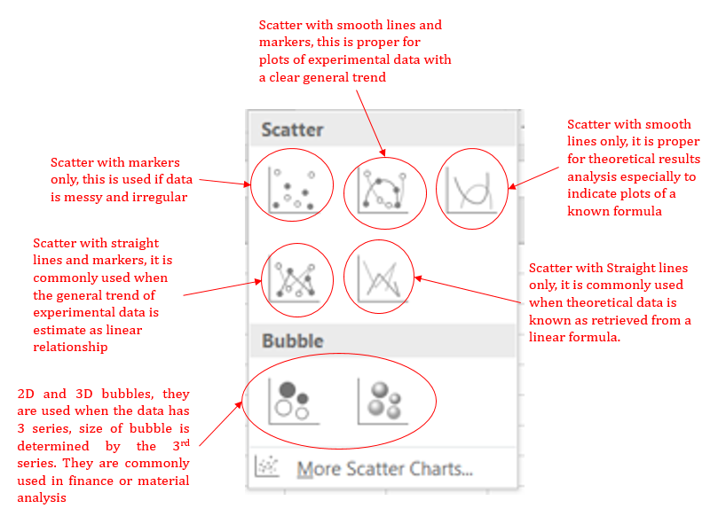.
Step 4
Select the “Scatter with Smooths Lines and Markers”, a white blank rectangle will appear. Right click it and choose “Select Data”.

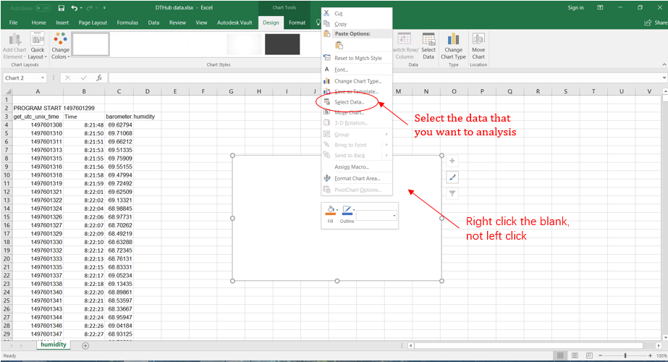

Step 5
Click on “Select Data”, a new window will appear, click the “Add” button.

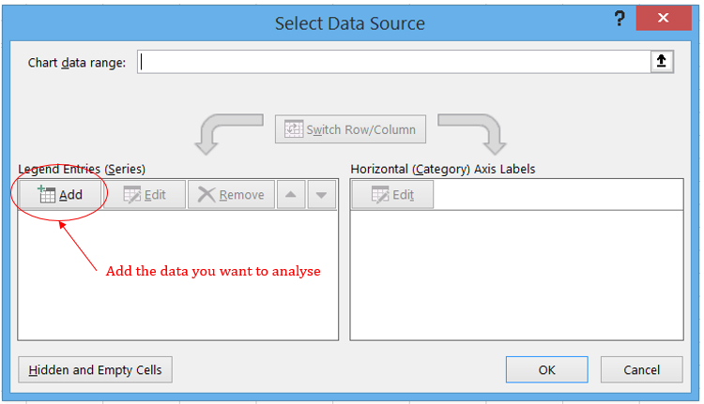

Step 6
After clicking “Add” button, another window will appear which can be used to define scope of data. Meanwhile, axis and primary undefined scale will appear on the blank. The three rows in “Edit Series” window can be input directly or retrieve the input information from excel by clicking that arrow button.
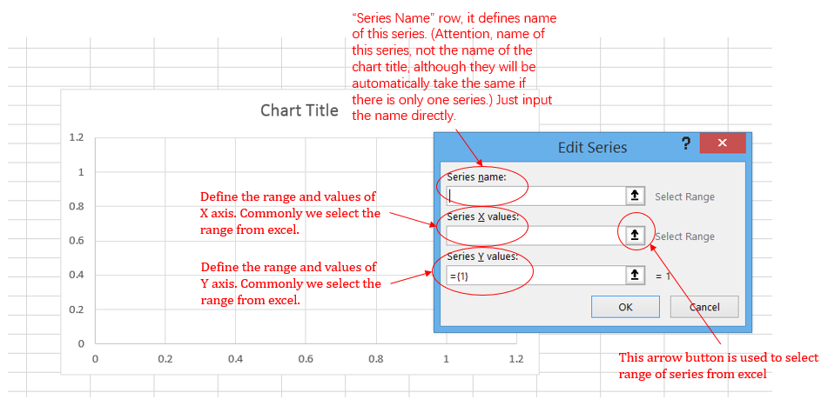

Step 7
Take the data of humidity as an example. Name the series as “Humidity vs Time”, which means humidity will go on the Vertical (Y) axis and time will Horizontal (X) axis.
Start from series X values, click that arrow button, a new small window will appear, now you can directly select data from excel. Start from the X axis which is Time column.
Move the mouse to the first block you want to start, hold the left button, drag it down the entire column and then release the mouse. The entire column of data points should be highlighted. The selected data will be indicated in the small window.
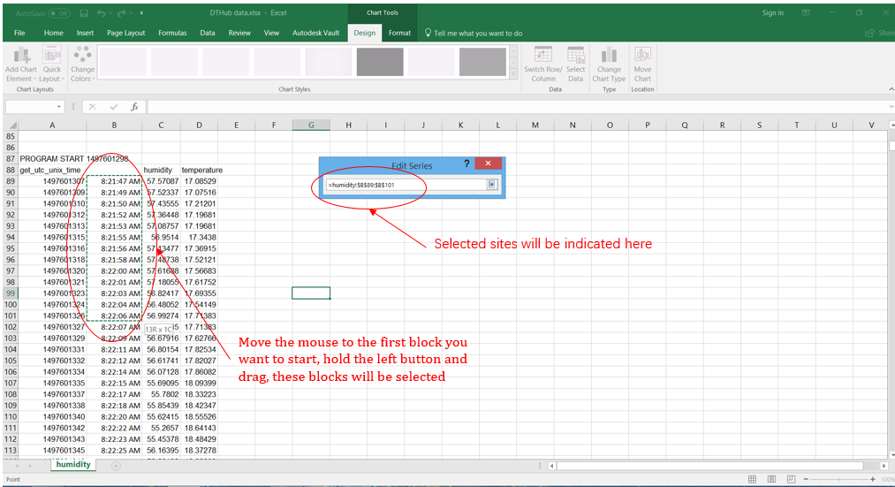
Step 8
You can drag column all the way to the last block that you need; however, this is only effective for smaller amounts of data. Currently we are working with too many data points, so this method will be too slow. Instead, move the screen to the last entry of this series, check the last row number and input that into the “Edit Series Window”.

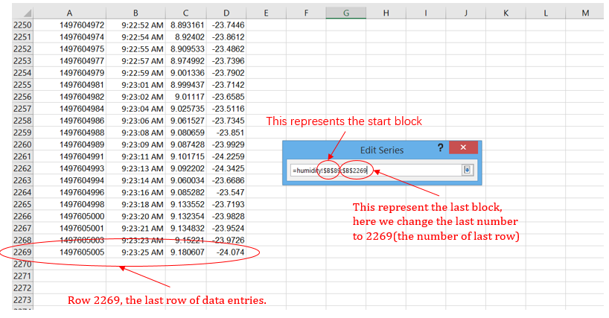

Step 9
Do the same thing to humidity column (Y Axis).

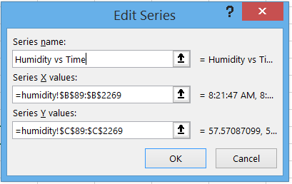

Step 10
Click the “OK” button, move back to the position of chart (that blank), it can be seen that data has been plotted.

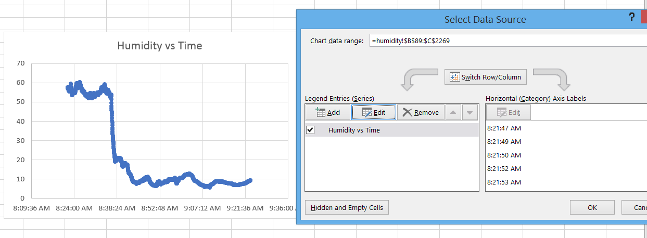

Step 11
You can edit the appearance of the chart, and make it look more professional. Click the chart, “Design” will appear on the top, select it and choose the “Quick Layout”.

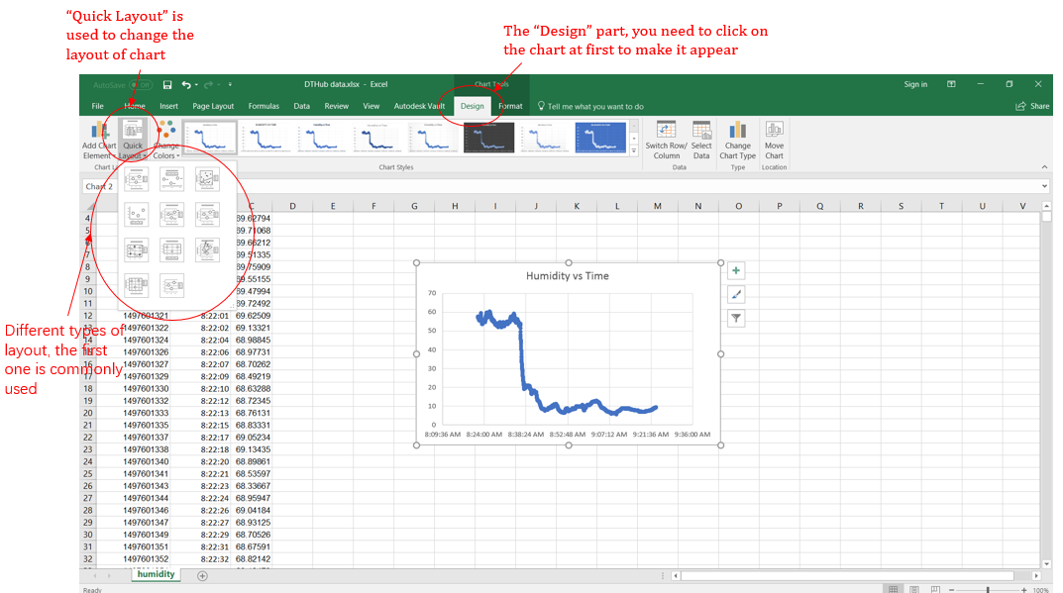

Step 12
Rename the axis and title. To do this, double click the axis titles and chart titles to change the content or delete.

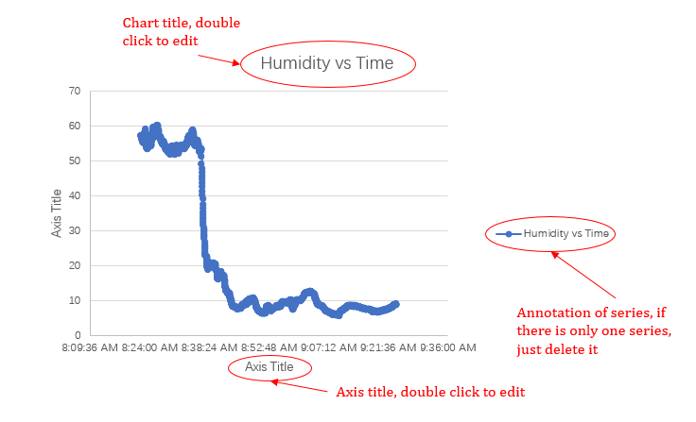

Step 13
To adjust any of the axis, double click it, “Format Axis” will appear at the right side.

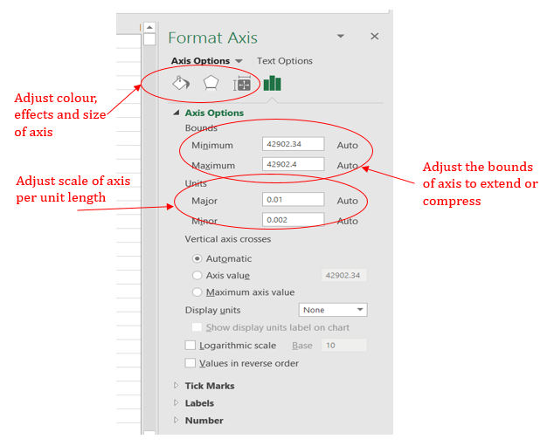

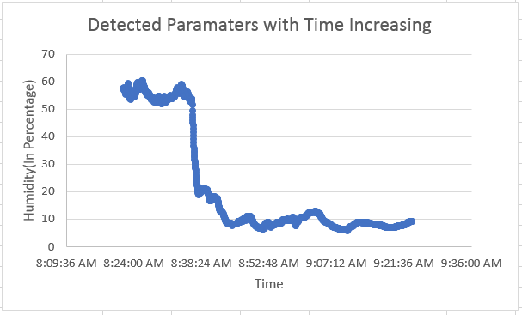

Step 14
Move to the next parameter, you can repeat all the steps above for each parameter to plot them separately. Meanwhile, you can plot all of them together in the same chart as well. Right click the chart again, select the “Select Data” and click “Add” button so that a new series will be inserted.

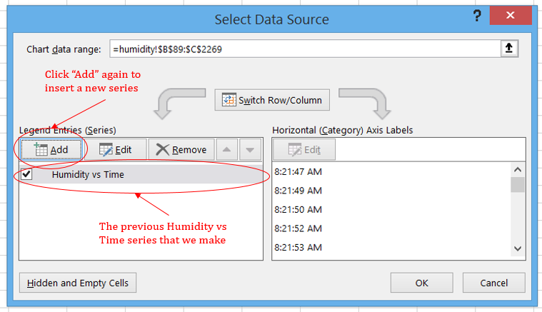

Step 15
Repeat previous steps, the only difference is that we select temperature columns as Y axis to make the new series.

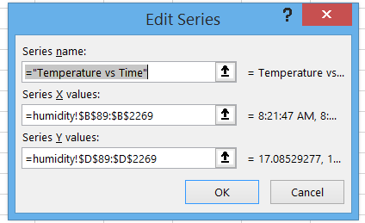

Step 16
Now we can see that there are two series of data plotted in the same chart indicated with different colour.

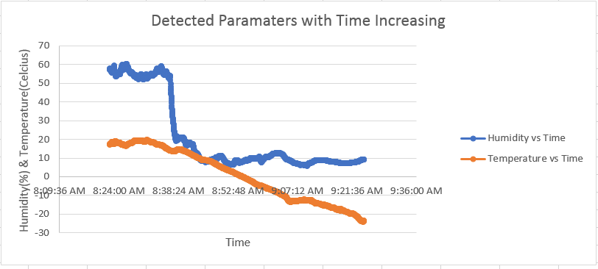

Step 17
Repeat steps 15 and 16 to insert series of Pressure vs Time. As the barometer failed to collect data after the balloon was launched for 5 minutes, the curve is much shorter and can not be used in this analysis. One issue is that numbers of entries of X axis and Y axis must be the same.

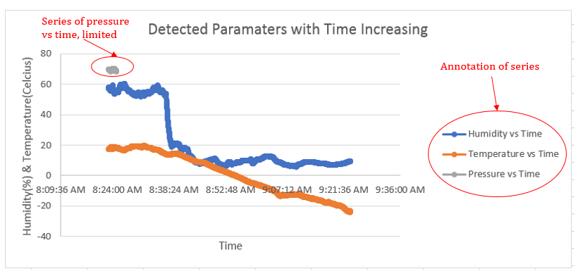

Step 18
The colours of the curves and dots can be changed as well. Left click on the curve and then right click, make sure that you select the whole curve but not just a single dot.

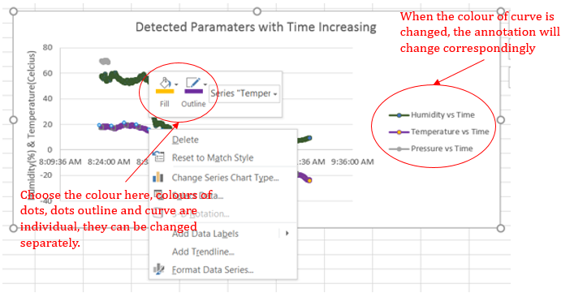

Step 19
If the three parameters are plotted separately, they will look like this. Plotting them together can benefit your analysis make and relationships or trends easier.

