Baringa State Primary School
Baringa State Primary School is a caring, inclusive and innovative learning community that empowers students to reach their full potential as global learners. Each member of our school community believes that every student can and will achieve. Baringa opened its doors at the start of 2018 as Education Queensland’s first purpose-built STEM school. A consistent approach to quality teaching, known as our 'signature practices', ensures that learning is seamless throughout the school. Our comprehensive framework incorporates direct instruction to inquiry learning, with a specific focus on cross-curricular STEM units taught every term, in every classroom. At Baringa we ‘Imagine, Discover, Together’.
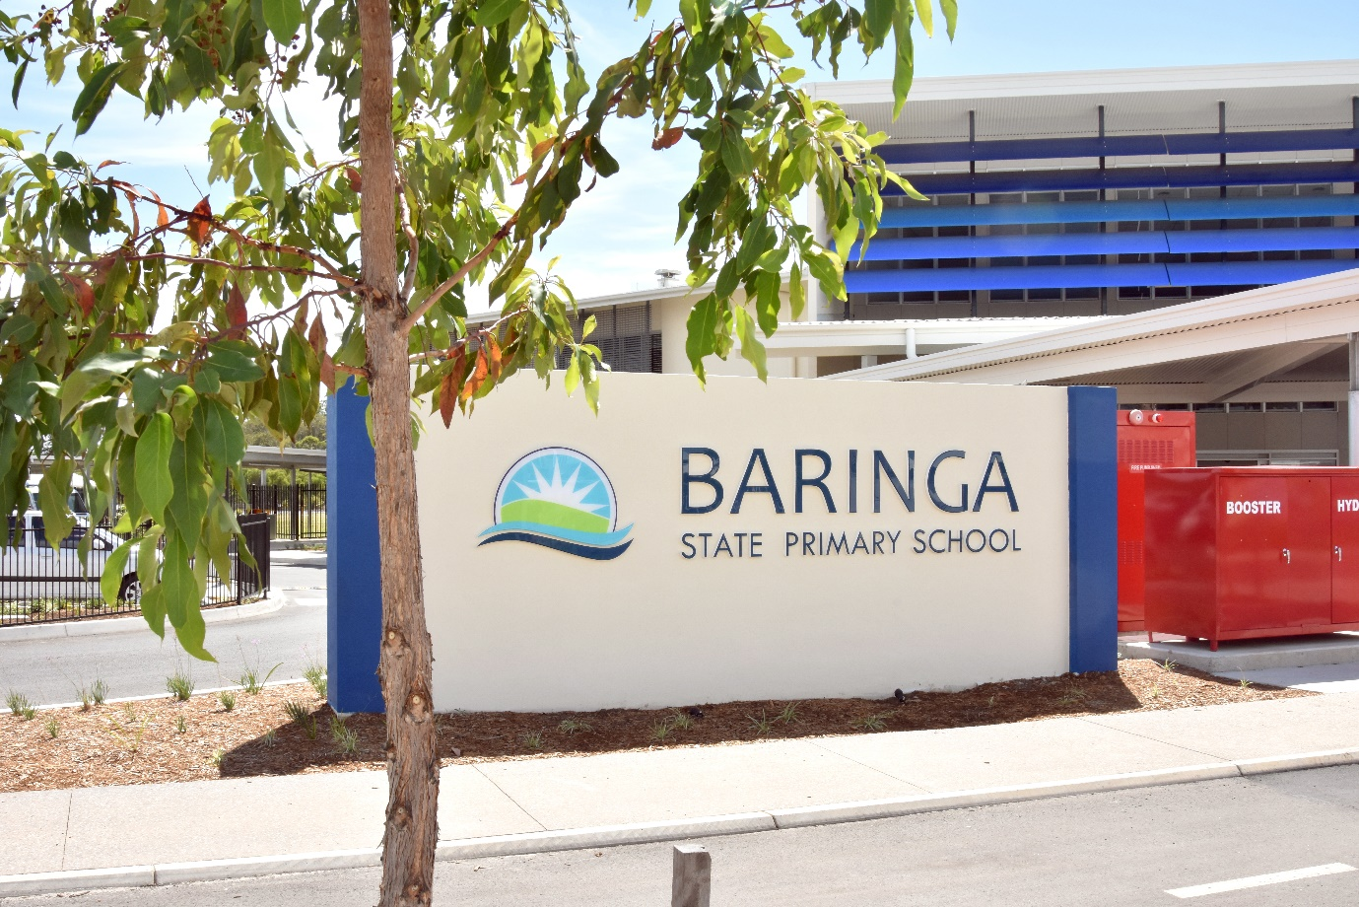
Implementation of STEM @ Baringa
As Education Queensland’s first STEM school, our STEM curriculum design is based on trust, openness and a futuristic approach to learning for every child. Students in all year levels are immersed in STEM subjects. Baringa uses a cross-disciplinary approach that integrates STEM disciplines around relevant contexts (ie a problem, question, product or issue), with a host key learning area based on the Australian Curriculum. Critical to our STEM agenda is developing a deep understanding in the key learning areas and building students’ capacity, willingness and resilience so that they can solve problems while being immersed in authentic learning environments. Through our STEM inquiry units, we not only build students' capacity to work with complex and unfamiliar problems, we encourage students to question and to wonder.
When planning a cross-disciplinary STEM unit we follow a sequence of steps.
- Know the Australian Curriculum and what it is that we are teaching and assessing.
- Identify a relevant context.
- Consider the achievement standards of the host learning area and any other assessable linked learning areas.
- Develop an integrated cross-curricular teaching sequence.
- Assess students' learning and report against the Australian Curriculum subject achievement standards.
- Evaluate the approach.
Modelling, coaching and developing staff capacity
Any school implementing curriculum reform, whether new or old, needs to consider the expertise and experiences of staff. At Baringa we believe in building teacher capacity to allow all teachers to embed our cross-disciplinary STEM units. It’s for this reason we have developed a culture of learning where STEM teachers and students believe that high expectations exist and that STEM skills are valuable to all students, and therefore are taught in every classroom. Teachers learn with students through a school-wide modelling, coaching and mentoring program. We believe that investing in our teachers’ knowledge and skillset is vital. All staff are involved in a modelling, coaching and mentoring capacity as we enable our teachers to become experts in different fields, creating an expert teaching team through distributed leadership. In STEM, this involves developing leaders and experts that can support other teachers in areas such as 3D printing and laser cutting, virtual and mixed reality, using tools such as Micro:bit, drones and robotics and embedding the ICT capabilities within our BYOD iPad program.

How does modelling and coaching make a difference?
Distributing leadership in STEM creates a culture of learning and allows for change. As educators, we are learners, teachers and leaders. We learn with and from each other in a non-threatening environment where it is okay to not know the answer and not be the expert. Not only does it help build and develop teachers' skills in STEM, it creates a culture of trust and openness where people are willing to accept and embrace change in curriculum delivery and teacher mindsets. In line with our school motto, it also allows teachers to ‘Imagine, Discover, Together’.
Interview with a teacher: Maree Case (Year 4)
What was your STEM knowledge before starting at Baringa?
I have been a classroom teacher for 14 years and prior to that a teacher aide for 7 years. Before starting at Baringa I had a very limited understanding of STEM – I knew it involved technology but I had never taught a STEM unit and had never taught any coding or robotics, let alone sensors and 3D printing.
How has the coaching and modelling process worked for you and your class?
The coaching and modelling has been integral for my learning. I have had the opportunity to have the HOC – Digital Engineer support me in class and have had access to a Year 6 teacher who is training to be knowledgeable in the use of the 3D printer. I’m a visual and kinaesthetic learner, so for me to observe colleagues who have knowledge and passion about STEM projects gives me the confidence to have a go at something completely foreign to my past pedagogical practices. I now feel confident in using the online and school resources and know that I have access to onsite support whenever I need it. I suppose the biggest drawcard for me has been having the opportunity to learn with my students.
What has been the biggest impact on student learning and engagement?
STEM exposes students to a variety of opportunities. It is hands-on and engaging. Many of my students, after just one lesson on ‘Tinkercad’, went home and began their own 3D design journey. They completed lessons and were even able to teach me some things. Using the cross-curricular perspective also means that it is relevant to what we are teaching and allows students to see how STEM can be applied in the real world instead as an add-on subject.
–Maree Case, Year 4 teacher, Baringa State Primary
Example cross-curricular units
Years 3–4: The Lighthouse Keeper's Lunch
Host subject area: Science
Linking subject areas: Digital and Design Technologies; Mathematics
Focus content descriptions:
Science | Technologies | Mathematics
Year 4  Natural and processed materials have a range of physical properties that can influence their use (ACSSU074)  Year 3  A change of state between solid and liquid can be caused by adding or removing heat (ACSSU046) | Digital Technologies  Define simple problems, and describe and follow a sequence of steps and decisions (algorithms) needed to solve them (ACTDIP010)  Implement simple digital solutions as visual programs with algorithms involving branching (decisions) and user input (ACTDIP011)  Design Technologies  Investigate food and fibre production and food technologies used in modern and traditional societies (ACTDEK012)  Plan a sequence of production steps when making designed solutions individually and collaboratively (ACTDEP018) | Year 4  Use scaled instruments to measure and compare lengths, masses, capacities and temperatures (ACMMG084)  Construct suitable data displays, with and without the use of digital technologies, from given or collected data. Include tables, column graphs and picture graphs where one picture can represent many data values (ACMSP096)  Year 3  Measure, order and compare objects using familiar metric units of length, mass and capacity (ACMMG061)  Collect data, organise into categories and create displays using lists, tables, picture graphs and simple column graphs, with and without the use of digital technologies (ACMSP069)

Unit overview
After reading the book The Lighthouse Keeper's Lunch, students in a Years 3–4 composite were set the challenge of designing a food package with a healthy cookie that they could safely deliver to Mr Grinling using drone technology.
In Science, students began testing the properties of materials in order to design a suitable package. Students then designed and created a lightweight package that could be transferred via drone. Before making the package, students tested how much weight the drone could carry using measured weights. Students' results were recorded in tables and graphs using digital technologies apps.
As part of the investigation, students also explored modern and traditional food technologies and designed a recipe to make a ‘healthy cookie’. They used scaled measures to bake their cookie and reflected on what old and new technologies they had used.
Once students had created their package they were given the challenge of delivering the package via a drone from 'Point A', through a hoop to a 'lighthouse' using visual block coding. Students' design production steps, scientific drawings, reflections and evidence were recorded in a digital journal that was submitted for assessment to demonstrate knowledge and understanding, scientific inquiry skills and design process and production skills in Science and Design Technologies.
To find out more about this unit visit the Baringa State Primary School’s YouTube channel: Teaching of STEM.

Year 4: Micro:bit unit – The ultimate plant watering system
Host subject area: Science
Linking subject areas: Digital and Design Technologies; Mathematics
Focus content descriptions:
Science | Technologies | Mathematics
Living things depend on each other and the environment to survive (ACSSU073)  Living things have life cycles (ACSSU072) | Digital Technologies  Define simple problems, and describe and follow a sequence of steps and decisions (algorithms) needed to solve them (ACTDIP010)  Implement simple digital solutions as visual programs with algorithms involving branching (decisions) and user input ACTDIP011)  Design Technologies  Recognise the role of people in design and technologies occupations and explore factors, including sustainability that impact on the design of products, services and environments to meet community needs (ACTKEK010) | Compare and describe two dimensional shapes that result from combining and splitting common shapes, with and without the use of digital technologies (ACMMG088)  Create symmetrical patterns, pictures and shapes with and without digital technologies (ACMMG091)  Construct suitable data displays, with and without the use of digital technologies, from given or collected data. Include tables, column graphs and picture graphs where one picture can represent many data values (ACMSP096)

Unit overview: How can we create the ultimate self-watering bee-attracting plant?
In Science students learned about the life cycles of animals and plants with a focus on the bee. They explored how bees and flowers are dependent on each other for survival. Students then planted their own flower seedling.
Students were introduced to the 3D printing software Tinkercad. In Tinkercad, they combined, joined and extruded 2D shapes for planning. They then designed a symmetrical pot, which was printed using a 3D printer. As part of the 3D printing exploration students also discussed and predicted future and current uses of 3D printing, the process and the differences and suitability of various filaments. While designing and printing, students explored measurement and were introduced to scale in order to print within the size requirements.
To create the self-watering component of the pot, students used the online tutorials available from the Micro:bit website to create the visual block coding. Students explored the digital systems in a Micro:bit sensor and used a moisture sensor to compile data from investigations into the moisture level of different soils. Results were then recorded in a graph using digital technologies. Using the results students created a plant watering system using a micro server and added these to their 3D printed pots to create a self-watering plant system that would activate when not enough moisture was present.

In Science, students were assessed on their knowledge of life cycles and their knowledge of the relationships that assist the survival of living things. In Design Technologies students were assessed on their design production and reflections and on their reflections on the suitability of the plant watering system in meeting community needs and future use. In this unit, Digital Technologies were not assessed but used as an introduction to Micro:bit sensors in real world applications.

Year 5: A virtual world – The wallum sedge frog
Host Subject area: Science
Linking subject areas: Digital and Design Technologies; Mathematics
Focus content descriptions:
Science | Technologies | Mathematics
Living things have structural features and adaptations that help them to survive in their environment (ACSSU043) | Digital Technologies  Examine the main components of common digital systems and how they may connect together to form networks to transmit data (ACTDIK014)  Implement digital solutions as simple visual programs involving branching, iteration (repetition), and user input (ACTDIP020)  Acquire, store and validate different types of data, and use a range of software to interpret and visualise data to create information (ACTDIP016)  Design a user interface for a digital system (ACTDIP018) | Pose questions and collect categorical or numerical data by observation or survey (ACMSP118)  Construct displays, including column graphs, dot plots and tables, appropriate for data type, with and without the use of digital technologies (ACMSP119)  Describe and interpret different data sets in context (ACMSP12)

Unit overview: How can we create a virtual environment to teach others about the adaptations and plight of a local endangered frog species, the wallum sedge frog?
As part of the Advance Queensland Engaging Science Grant, Baringa State Primary School purchased a kit of virtual reality (VR) glasses, phones and a licence to CoSpaces Edu.
The wallum sedge frog is Baringa State Primary School’s behaviour mascot and is a local endangered frog species. As the school has been built in a developing estate students have identified the need to teach others about the local frog species and its plight. Due to the development, local frog habitats have been impacted and as a result local scientists and the community have created new frog habitats to rebuild the number of frog species in the area.
Working with local scientists, students used sensors to obtain data on frog callings in the area and tested the pH levels in local frog ponds. Students analysed the data and created a digital spreadsheet to record the callings of not only the wallum sedge frog but other local frog species.
Using 360 photography of the local frog ponds and the online VR space – CoSpaces Edu – students created virtual environments to teach others about the adaptations and habitats of the wallum sedge frog. Within CoSpaces, students created a user interface that replicated the frog habitat, while providing a way to inform the community about the frog's plight. Within CoSpaces Edu students also incorporated visual block coding to include moving components such as jumping frogs.
Using a virtual environment ensures we can teach others about the endangered species without impacting on the protected habitats of the wallum sedge frog.
Please note: Baringa State Primary School purchased a kit of VR glasses, phones and a licence to CoSpaces Edu as part of the Advance Queensland Engaging Science Grant.
Safety considerations
Substantial research has been conducted into the safe use of VR in primary schools. As a result, Baringa has conducted a risk assessment into the use of VR within the curriculum and ensures all teachers using VR adhere to the following:
- When using VR headsets, the headpiece elastic is to be removed to allow quick removal of the VR headset.
- Students are to remain supervised while wearing a headset.
- Students are not to wear the headset for more than 3 minutes without removing it for a short break.
- If students experience any discomfort or motion sickness the VR experience is to cease immediately.
- Motion VR apps will not be used while at school, eg rollercoaster VR experiences.
- Classroom VR headsets are to be phone-based only as most computer-controlled VR headsets have a 13+ age rating.

What advice would you give anyone wishing to undertake a similar project?
My advice to schools wanting to implement a cross-curricular STEM approach would be:
- Tip1: Decide on a host subject area: To embed STEM as a cross-disciplinary approach you don’t have to completely change your curriculum. Decide on a host subject such as Science and look for ways to bring in Digital and Design Technologies. You will be surprised how often Mathematics also aligns nicely with a cross-disciplinary approach.

- Tip 2: Assess in key learning areas: With an already overcrowded curriculum, when developing assessment ensure that the task or tasks allow you to assess against the Australian Curriculum achievement standards in not only the host subject but Digital or Design Technologies (or both).

- Tip 3: Reflect, change, improve: At Baringa our STEM units are always in draft. Be prepared to take the time to reflect on your units, modify and improve. Be flexible and ask teachers and students for feedback.

- Tip 4: Build an expert teaching team and a culture of learning: Teachers don’t need to be experts in everything STEM, but they need to have a trusting and open team around them that can support, provide guidance and help mentor. Ensure teachers know that it’s okay to be a novice; after all, your teachers are the most valuable resource you have in a school. Invest the time to develop them. It will be worth it!

