Title: Skip counting with Bee-Bots
SUB HEADING: Program a robotic device to follow a path
Summary Text: Play a skip counting game where students program the Bee-Bot to stop at multiples of a set number, eg 2, 4, 5, 10 on a number grid.
Year Level: F–2
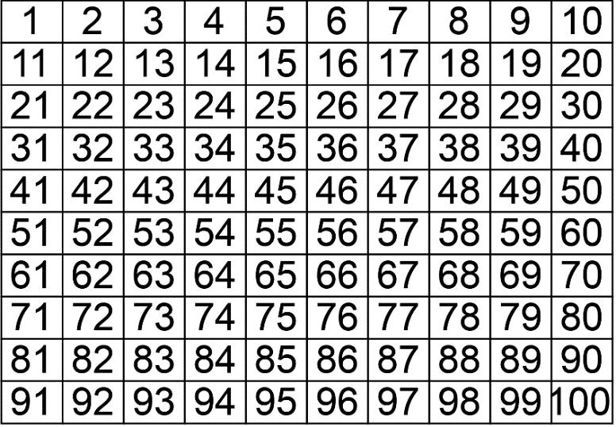
<Alt text> A number grid arranged in rows 10 x 10

Suggested steps
- Use a number board to practise counting number sequences to and from 100. Skip count by twos, fives and tens, both forwards and backwards. Students use the number sequences to program the Bee-Bot to start on zero and stop on each multiple, using a correct sequence, eg multiples of 5 (5,10,15,20,25,30).
- Differentiate to suit learners’ ability by increasing the complexity of the task, eg start from any starting point; use other number sequences.

Discussion
- Consider the factors that led to success or failure. Emphasise the importance of clear and precise instructions.
- Ask why it is important to test and retest programs.

Why is this relevant?
This activity is an authentic way to introduce students to simple programming while consolidating number concepts. It focuses on developing foundational skills in computational thinking and on developing an awareness of digital systems through personal experience of them.
F–2 students should be provided with the opportunities to explore new concepts such as algorithms through guided play, including hands-on, kinaesthetic and interactive learning experiences. Students begin to develop their design skills by conceptualising algorithms as a sequence of steps/procedures for carrying out instructions to solve a problem or achieve something, such as identifying steps in a process or controlling the Bee-Bot.
At the F–2 level, where learning at the pre-programming stage is the expectation, there is no requirement to learn a particular programming language. However, students do learn some basic programming skills such as working out steps and decisions required to solve simple problems. For example, they program a robotic toy or sprite to move in a certain direction. The focus at this level is on designing a sequence of steps.

Assessment

Teacher assesment
Use a simple checklist to evaluate achievement.
Can the student:
- describe the functions of the Bee-Bot?
- design a correct sequence of instructions?
- select the appropriate buttons to program a Bee-Bot to follow a simple path?
- describe the purpose of programming a Bee-Bot?
- use directional language correctly?

Australian Curriculum Alignment

Mathematics

Number and place value
Develop confidence with number sequences to and from 100 by ones from any starting point. Skip count by twos, fives and tens starting from zero (ACMNA012)
Investigate number sequences, initially those increasing and decreasing by twos, threes, fives and tens from any starting point, then moving to other sequences (ACMNA026)

Location and transformation
Describe position and movement (ACMMG010)
Give and follow directions to familiar locations (ACMMG023)

Technologies – Digital Technologies
Follow, describe and represent a sequence of steps and decisions (algorithms) needed to solve simple problems (ACTDIP004)
Recognise and explore digital systems (hardware and software components) for a purpose (ACTDIK001)

ICT Capability
Typically, by the end of Year 2, students:

Select and use hardware and software
Identify and safely operate a selected range of appropriate devices, software, functions and commands when operating an ICT system and attempt to solve a problem before seeking help

