Introduction to Ozobot and Colour Codes

Year level band: F-2 (can also be adapted for 3-4 and 5-6 as a first lesson with Ozobot)

Description: Students are introduced to Ozobot and how drawing lines and colour codes can control it. This lesson allows students to experiment with different lines and codes to create a path for Ozobot to follow.

Resources:
- Ozobots
- Blank white paper
- Markers/textas in colours black, red, light blue and light green (recommended: Ozobot pens, Sharpie wide chisel tip or Crayola markers), one set per group
- Colour codes downloaded and printed
(http://files.ozobot.com/stem-education/ozobot-ozocodes-reference.pdf)
- Ozobot activity sheets (pages 8-10 of https://storage.googleapis.com/ozobot-lesson- library/programming-with-colors/programming-with-colors.pdf )

(Instead of paper, you can also code Ozobot by drawing on tablets, using apps such as Explain Everything or OneNote.)

Prior Student Learning:
Maths: Students have done some work on navigational language (left, right, forward, backward).

Digital Technologies: It may be that students have done some prior unplugged algorithms (simple following and providing instructions).

By the end of Year 2, students will have had opportunities to create a range of digital solutions through
guided play and integrated learning, such as using robotic toys to navigate a map.
Students use the concept of abstraction when defining problems, to identify the most important
information, such as the significant steps involved in navigating a robot. They begin to develop their
design skills by conceptualising algorithms as a sequence of steps for carrying out instructions, such
as identifying steps in a process or controlling robotic devices. Students are able to use data as an
input for their robotic device.
Year | Content Descriptors
F-2 | Follow and describe algorithms involving a sequence of steps, branching (decisions) and iteration (repetition) (AC9TDI2P02) .

Element | Summary of tasks
Learning hook | Introduce Ozobot and explain how the robot works.  With a black marker, draw a line and show how Ozobot follows it. Repeat for other colours.  Show Ozobots sensors on the bottom and explain that these are its eyes – it can follow lines and can see different colours.  Draw crossing lines (or use print out) and ask students to predict what will happen when Ozobot reaches a junction.  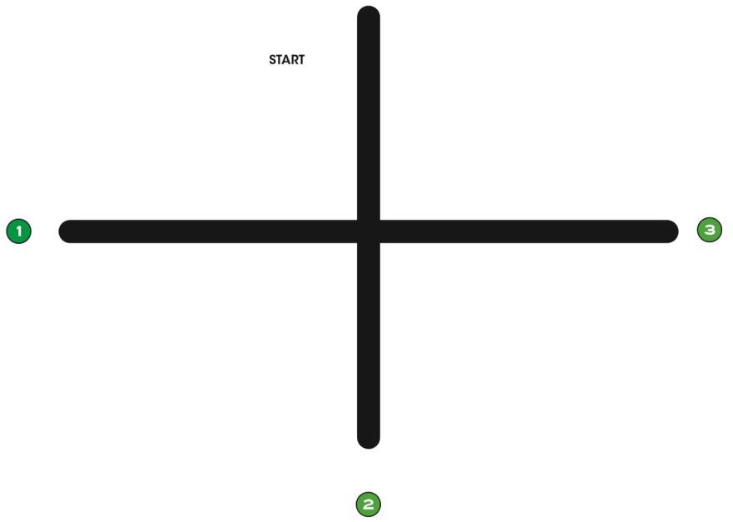  Place Ozobot at the start, and repeat a few times. The turn is random, so run enough times to demonstrate this.  Were your predictions correct?
Achievement Standards | By the end of Year 2, students design solutions to simple problems using a sequence of steps and decisions.

Learning Map (Sequence) | - Students describe the sequence of turns that Ozobot needs to make.  - Students work in teams to design their algorithm using a sequence of colour codes, that navigate Ozobot along a path.  - Students can draw paths, including colour codes and control Ozobot along the paths.  - Students can debug their algorithms and troubleshoot (line thickness, calibration etc.)
Learning input | Show how colour codes work. Demonstrate “Go right’ and ‘Fast’ as examples.  Explain that students are going to construct their own paths and make some paths for Ozobot to follow.  Ozobot is quite fussy, so you’ll need to work out how thick the lines need to be and what size to draw the colour codes.  Suggest checking that ink is dry before putting Ozobot on the line.
Learning construction | Students understand that Ozobots have sensors and follow lines and colour code instructions.  They work in small groups or pairs to construct paths using paper and coloured pens. This is an opportunity for students to play and find out how to control the Ozobots.  Have codes printed and available or displayed at the front of the class. Example codes to start with:  Go Left, Go Straight, Go Right, Slow, Fast, U-turn As students draw lines, teacher asks questions:  - Why did you draw this bit?  - What would happen if you added a line here?  - Would Ozobot always go that way? (Perhaps have available some copies of activity sheet 3 from  https://storage.googleapis.com/ozobot-lesson-library/programming-with-  colors/programming-with-colors.pdf)
Learning demo | Once students have got working drawings and solved any problems, choose a couple of groups to present what they have created with the class:  - What does Ozobot do?  - What did you discover about the lines or codes?  - What worked well?  - What did not work well?  - Did you change anything?

Learning reflection | Bring together the observations from the learning demo and, with the students, come up with a list of rules, e.g.  - Thickness of the lines  - What size the codes need to be  - What works and doesn’t work with the lines (e.g. curves, turns etc.)

Assessment:
Formative Assessment:
- Teachers observe students using the Ozobots, creating their algorithms and debugging.
- Use questioning to elicit student understanding of the functions of the Ozobot and their algorithmic thinking.
- You might take photos of the students’ work to document their progress, or record the Ozobot in their final demonstration.

 | Quantity of knowledge |  |  | Quality of understanding
Criteria | Pre- structural | Uni- structural | Multi- structural | Relational | Extended abstract
Algorithms Codes | No algorithm or colour codes shown | Algorithm only shows a limited number of instructions which are  not linked – possibly use of different colour lines | Algorithm has enough instructions to complete the task but not linked or not linked in the correct sequence – or there are codes that do not work | Algorithm has instructions linked in the correct sequence to achieve the  task – Ozobot can follow a path as designed using colour codes | Algorithm brings in prior learning and/or independent learning beyond the task and possibly includes additional colour codes
Vocabulary | When describing | The terms instruction or code may be used as a general description | The term | The terms | Specific vocabulary like decisions and repetition is used, going beyond the set language
 | algorithm, no |  | algorithm is | algorithm is used
 | specific |  | used as a | confidently with
 | vocabulary is |  | general | specific reference
 | used |  | description | to learner’s work

Teacher/Student Instructions:
It is useful for teachers to have read the Teacher Guide prior to using Ozobots with students: http://files.ozobot.com/stem-education/ozobot-teachers-guide.pdf
Teachers may want to explain calibration with the students, or you could make sure each Ozobot is calibrated at the start of the lesson.

CSER Professional Learning:
This lesson plan corresponds to professional learning in the following CSER Digital Technologies MOOCs: F-6 Digital Technologies: Foundations
- Unit 7: Algorithms and Programming F-6 Digital Technologies: Extended
- Unit 2: Algorithms & Programming See: http://csermoocs.adelaide.edu.au/moocs

Further Resources:
Ozobot Lesson Library (new lessons added monthly): http://portal.ozobot.com/lessons

Author: Steven Payne
This work is licensed under a Creative Commons Attribution-NonCommercial 4.0 International License. Computer Science Education Research (CSER) Group, The University of Adelaide.

